Kubernetes

Guided Lab 01: Creating Your First Pod in Kubernetes
Understand what a Pod is and how to create one using both imperative and declarative methods.

Welcome to Your First Pod Lab
In Kubernetes, a Pod is the smallest, most basic deployable unit. You can think of it like a wrapper around your container — it’s what Kubernetes uses to run your app.
Today, we’re going to create our very first Pod. And we’ll do it in two different ways:
- First, using the imperative method — where we tell Kubernetes exactly what to do, right from the command line.
- Then, we’ll shift to the declarative approach — where we write down our desired state in a YAML file and let Kubernetes take it from there.
This lab is not just about running commands. It’s about understanding how Kubernetes thinks.

Step 1: Set Up Your Lab Folder
Let’s keep things clean and organized. First, open your terminal and create a folder where you’ll store all your Pod-related files.
mkdir -p ~/k8s-labs/pods
cd ~/k8s-labs/pods
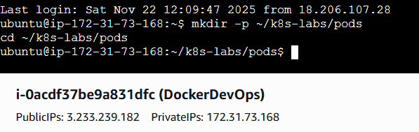
Now you're inside a working directory that’s dedicated to Pods. This is where we’ll do all our work for this lab.

Part 1: Creating a Pod Imperatively
Let’s start with the quickest way to create a Pod — using the kubectl run command.
kubectl run nginx-pod --image=nginx
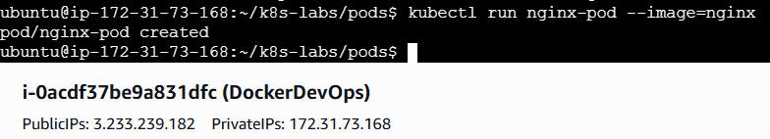
What’s happening here?
- kubectl run is a quick way to spin up a Pod.
- nginx-pod is the name we’re giving to the Pod.
- --image=nginx tells Kubernetes to pull the official NGINX image from Docker Hub.
Once you run this, Kubernetes will schedule a Pod named nginx-pod, and run a single container based on the NGINX image.
You can check if it’s running with:
kubectl get pods
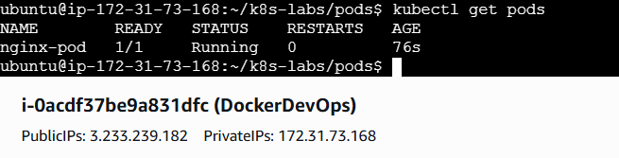
That’s it — you’ve just created your first Pod.
Now, let’s delete it so we can learn how to do the same thing declaratively.
kubectl delete pod nginx-pod
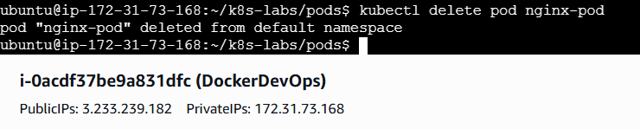

Part 2: Creating a Pod Declaratively (YAML-based)
The declarative method is how Kubernetes is meant to be used in the real world — especially in production.
Let’s write our desired state in a YAML file, then ask Kubernetes to create it for us.
Step 1: Create a new YAML file
touch nginx-pod.yaml
Now open this file in your preferred editor (nano, vim, or VS Code). For example:
nano nginx-pod.yaml
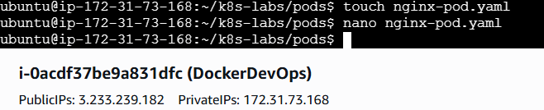
Step 2: Add the following content:
apiVersion: v1
kind: Pod
metadata:
name: nginx-pod
labels:
app: nginx
spec:
containers:
- name: nginx-container
image: nginx
ports:
- containerPort: 80
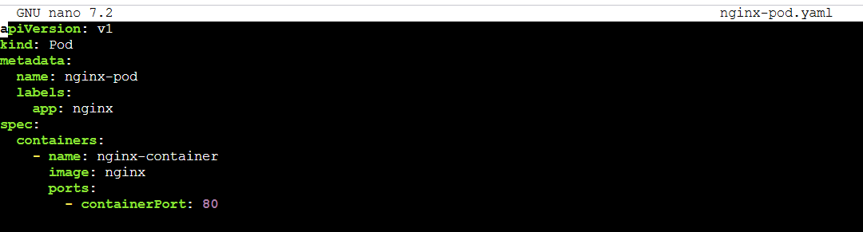
What’s going on in this file?
- apiVersion: v1 means this is using the core Kubernetes API.
- kind: Pod tells Kubernetes we want to create a Pod.
- metadata.name sets the Pod’s name.
- labels help identify this Pod (we’ll use this later with Services and Selectors).
- spec.containers defines the container(s) inside the Pod. In our case, just one — running the NGINX image.
Step 3: Apply the YAML
Now that we’ve written our desired state, let’s tell Kubernetes to make it real:
kubectl apply -f nginx-pod.yaml
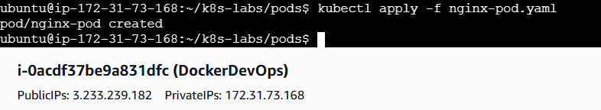
And check the result:
kubectl get pods
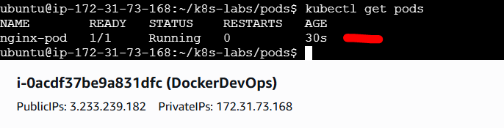
You should see your nginx-pod running just like before — but this time, it came from your YAML definition.

Bonus Step: Peek Into the Pod
Want to see more details about your running Pod?
kubectl describe pod nginx-pod
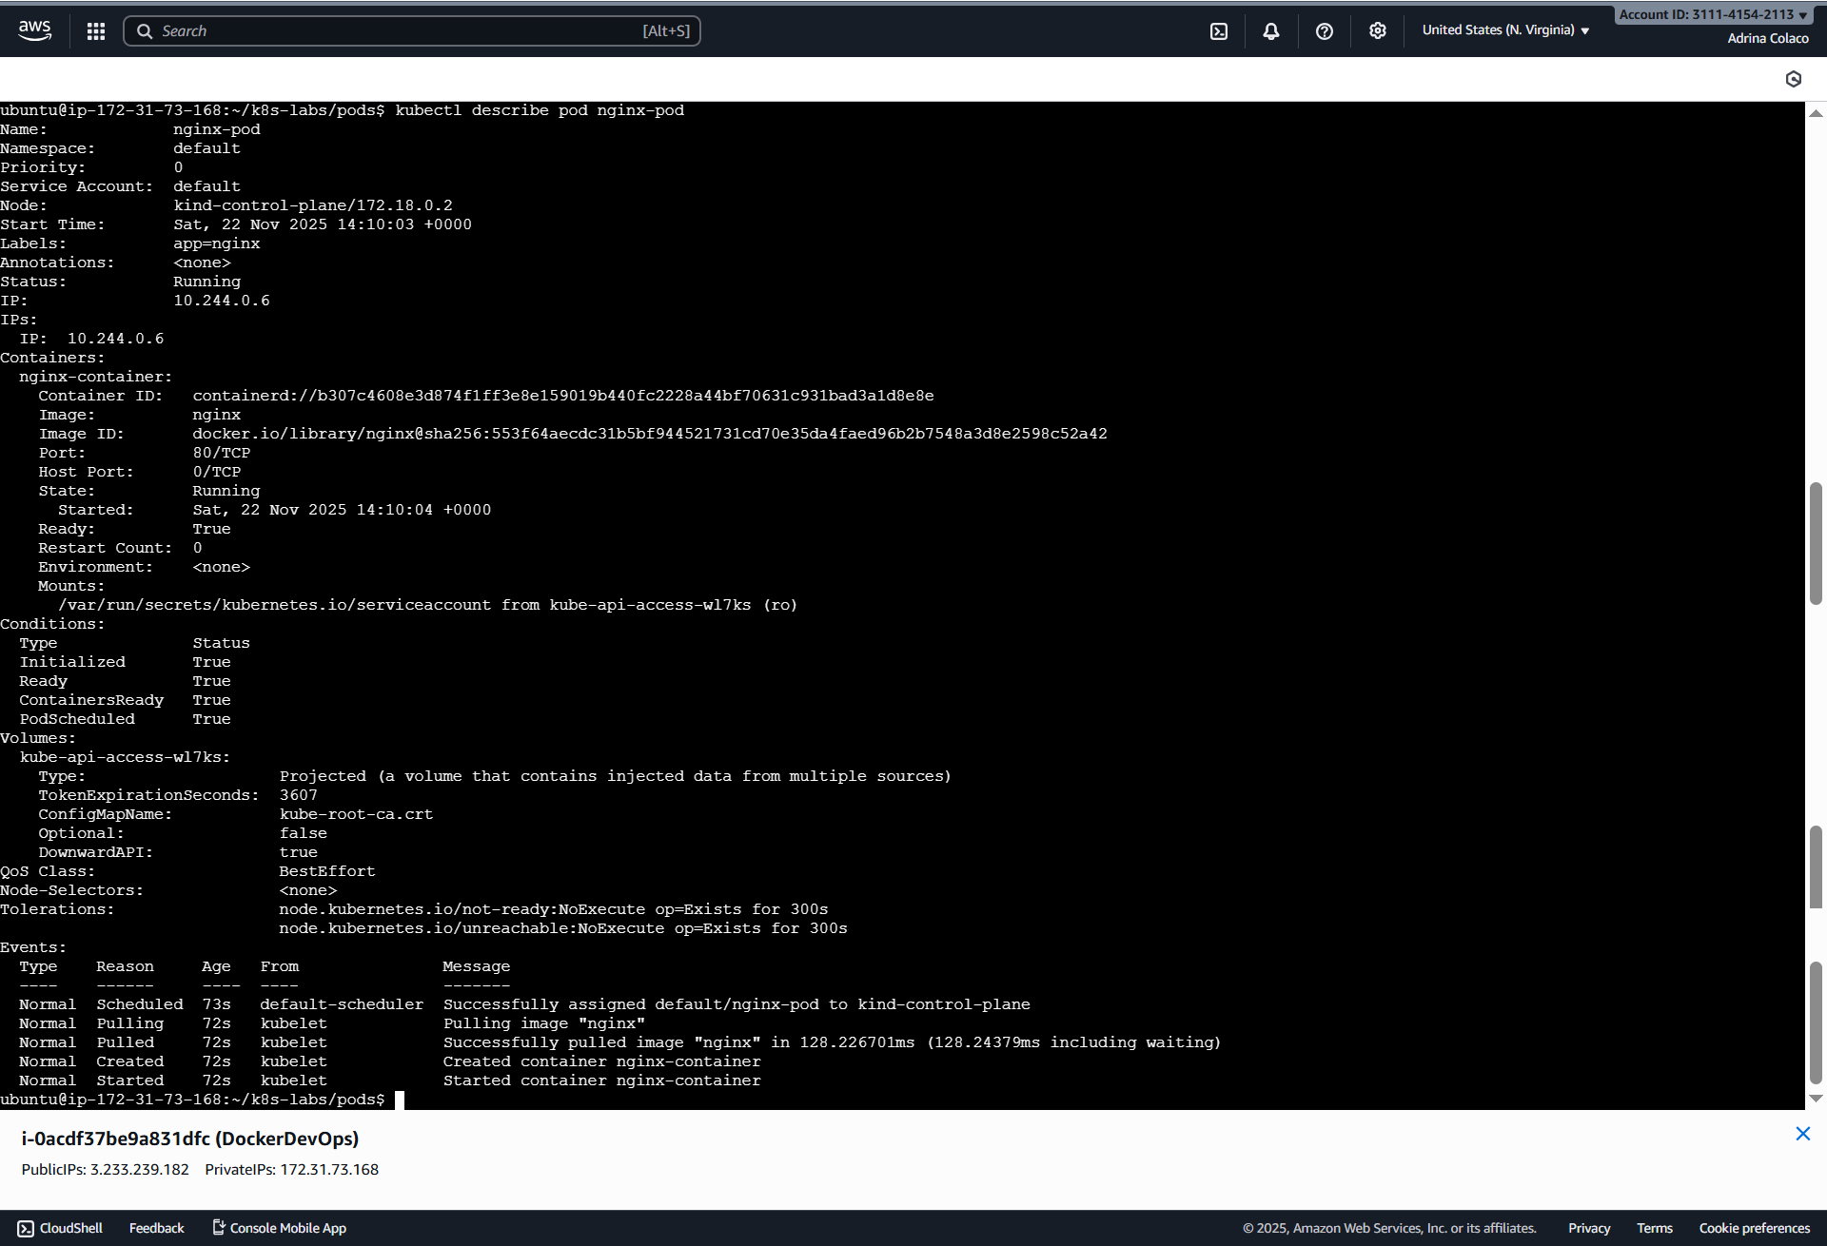
Or check logs from the container:
kubectl logs nginx-pod
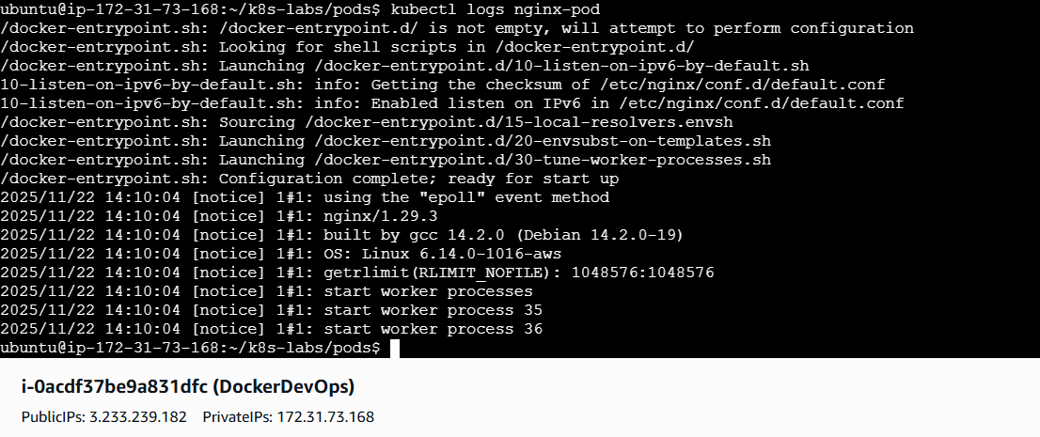
Want to get a shell inside the container?
kubectl exec -it nginx-pod -- /bin/bash
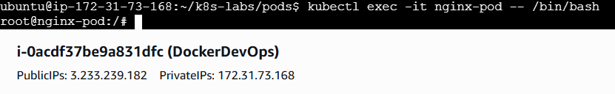
Try browsing to /usr/share/nginx/html inside the container. That’s where the default NGINX page lives.
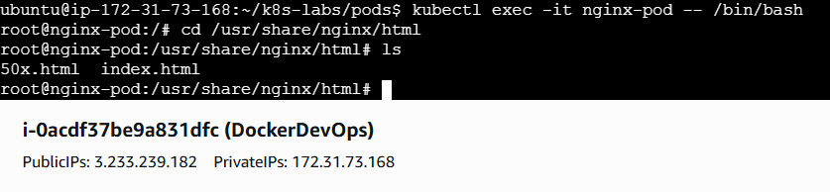

Wrap-Up: What Did You Learn?
- A Pod is the most basic unit in Kubernetes that runs your container.
- You created a Pod two ways:
  - Imperative: Quick, CLI-based
  - Declarative: YAML-driven, scalable, and production-ready
- You practiced creating, deleting, inspecting, and debugging a Pod

What’s Next?
Next, we’ll learn about ReplicaSets, which add resilience by ensuring that your Pods stay alive — even if one crashes. We'll also show how this leads naturally to Deployments and rolling updates.

Guided Lab 02: ReplicaSets – Keeping Your Pods Alive

Welcome to ReplicaSets
In our last lab, we created a single Pod. But here’s the problem: if that Pod crashes or is deleted… it’s gone. You’d have to manually re-create it. That doesn’t scale, and it’s certainly not what we want in a production system.
This is where ReplicaSets come in.
A ReplicaSet ensures that N copies of a Pod are always running — no more, no less.
If one Pod dies, the ReplicaSet spins up another to replace it. Think of it like Kubernetes’ way of keeping your app alive, automatically.

Step 1: Set Up Your Working Directory
Let’s keep our labs organized.
cd ~/k8s-labs
mkdir -p replicasets
cd replicasets
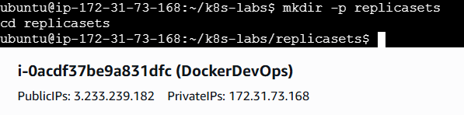

Part 1: Writing a ReplicaSet YAML
We’ll create a ReplicaSet that runs 3 NGINX Pods and automatically recovers them if any fail or are deleted.
Step 1: Create the file
touch nginx-replicaset.yaml
Then open it:
nano nginx-replicaset.yaml
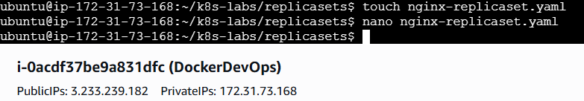
Step 2: Add the following YAML
apiVersion: apps/v1
kind: ReplicaSet
metadata:
name: nginx-replicaset
labels:
app: nginx
spec:
replicas: 3
selector:
matchLabels:
app: nginx
template:
metadata:
labels:
app: nginx
spec:
containers:
- name: nginx
image: nginx:1.21.1
ports:
- containerPort: 80
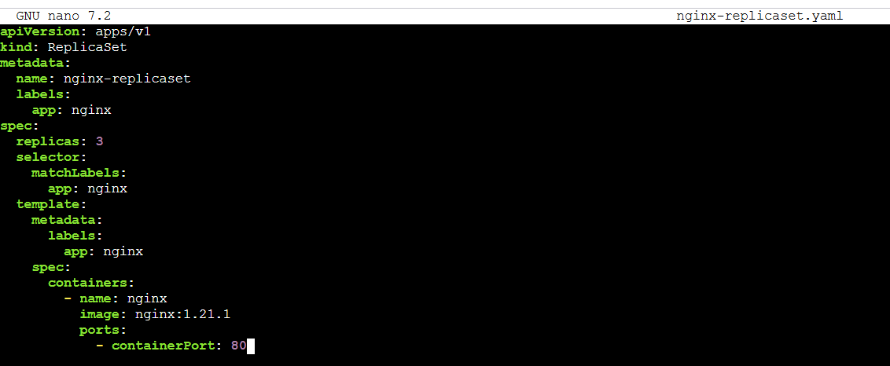

What’s happening here?
- replicas: 3 tells Kubernetes: “I want three copies of this Pod.”
- selector.matchLabels defines which Pods this ReplicaSet is responsible for. It must match the labels in the Pod template.
- template defines what each Pod should look like — same as the one we created earlier.

Step 3: Apply the ReplicaSet
kubectl apply -f nginx-replicaset.yaml
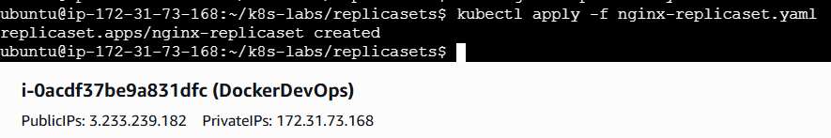
Now check if your Pods are running:
kubectl get pods
You should see three Pods created by the ReplicaSet.
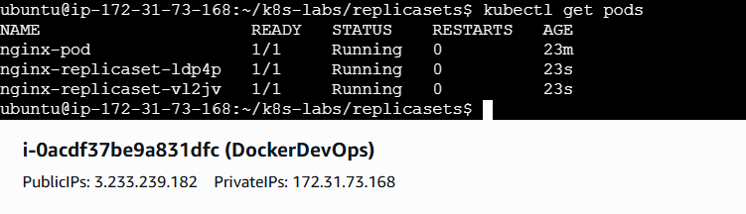

Part 2: Let’s Test the Healing Power
Now let’s simulate a failure. Delete one of the Pods:
kubectl delete pod <one-of-the-pod-names>
Then immediately run:
kubectl get pods
You’ll see Kubernetes automatically recreates the deleted Pod to maintain 3 replicas. This is auto-healing in action — powered by the ReplicaSet.
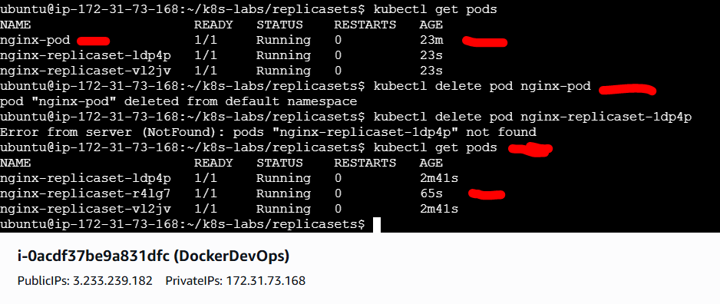

Bonus: Scaling Up Manually
Want more Pods?
You can edit the YAML and change:
replicas: 3
to:
replicas: 5
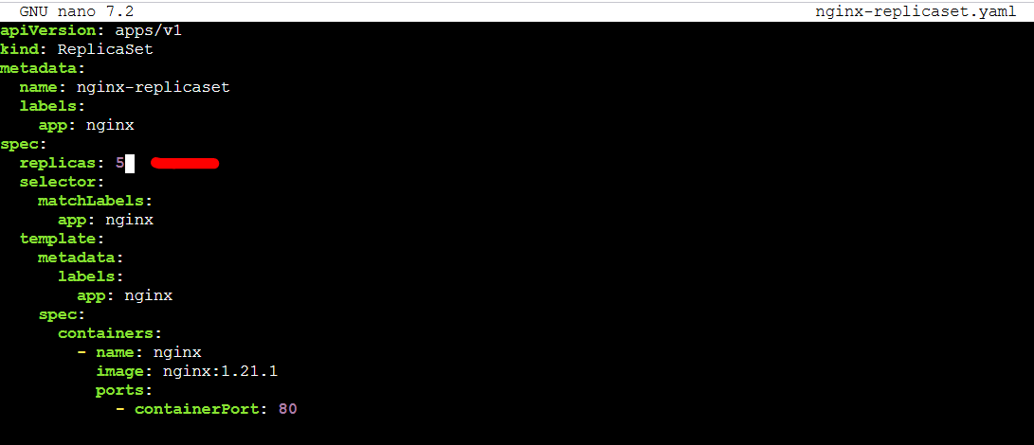
Then reapply:
kubectl apply -f nginx-replicaset.yaml
kubectl get pods
Now you'll see five NGINX Pods, all managed by the same ReplicaSet.
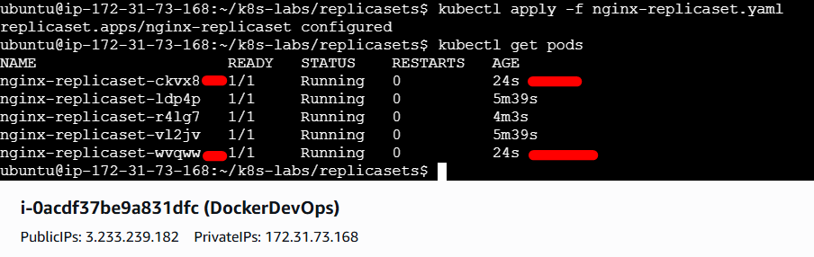

Useful Commands Recap
kubectl get replicaset
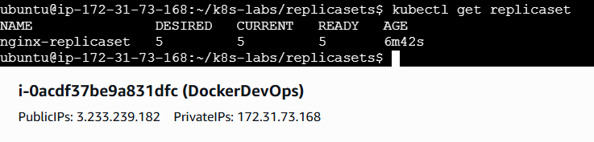
kubectl describe replicaset nginx-replicaset
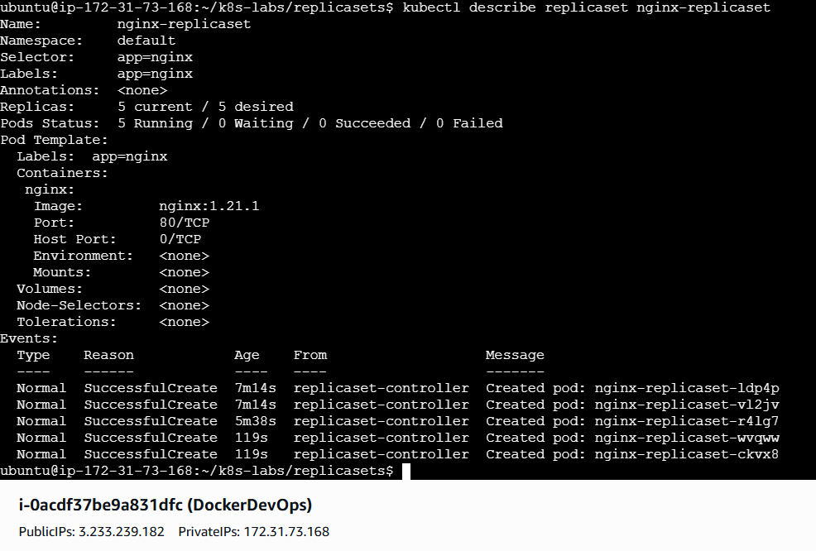
kubectl delete replicaset nginx-replicaset
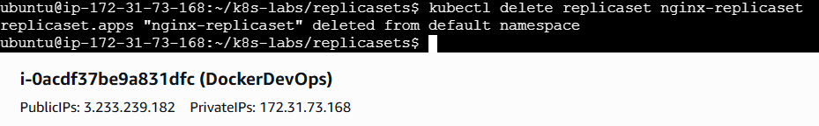
To see which ReplicaSet owns your Pod:
kubectl get pods -o wide
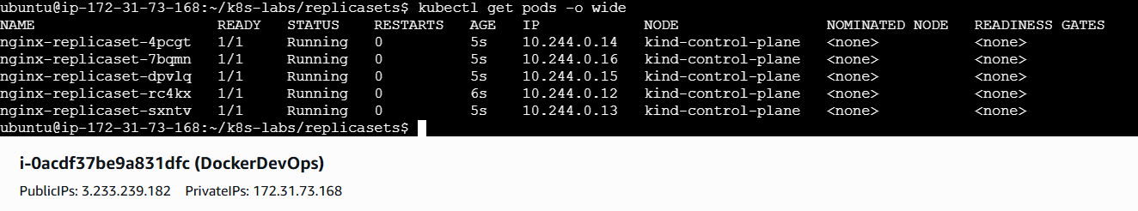

Wrap-Up: What Did You Learn?
- ReplicaSet ensures a fixed number of Pod replicas are always running
- If a Pod is deleted or crashes, ReplicaSet auto-heals it
- You can scale manually by changing the replicas count
- ReplicaSets are good, but they don’t support rolling updates or rollback — which leads us to Deployments

What’s Next?
In the next lab, we’ll explore Deployments, which sit on top of ReplicaSets and bring production-grade features like rolling updates and rollbacks.
They are the recommended way to manage your apps in Kubernetes today.

Guided Lab 03: Deployments – From Basics to Rolling Updates

Welcome to Deployments
Previously, we saw how ReplicaSets help keep Pods alive. But in a real-world application, that’s just the beginning.
In production, we need:
- Version control
- Easy updates with zero downtime
- Rollbacks if things go wrong
- Seamless scaling
All of this comes from a Deployment, not just a ReplicaSet.
So in this lab, we’re going to start simple — then layer in powerful features step by step.

Step 1: Set Up Your Working Directory
cd ~/k8s-labs
mkdir -p deployments
cd deployments
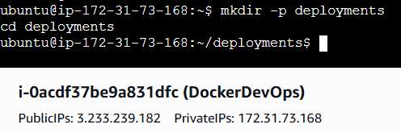

Part 1: A Simple Deployment (Your Production Starting Point)
Let’s start with a basic NGINX Deployment with 2 replicas.
Step 1: Create the file
touch nginx-deployment.yaml
nano nginx-deployment.yaml
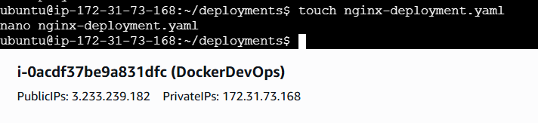
Step 2: Add the following content
apiVersion: apps/v1
kind: Deployment
metadata:
name: nginx-deployment
labels:
app: nginx
spec:
replicas: 2
selector:
matchLabels:
app: nginx
template:
metadata:
labels:
app: nginx
spec:
containers:
- name: nginx
image: nginx:1.21.1
ports:
- containerPort: 80
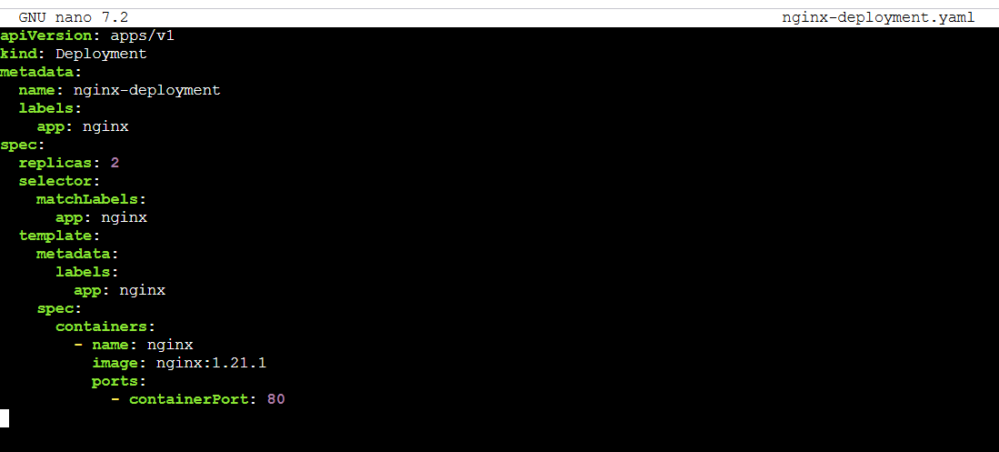
Step 3: Apply it
kubectl apply -f nginx-deployment.yaml
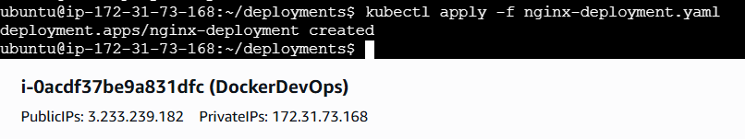
Then verify:
kubectl get deployments
kubectl get replicasets
kubectl get pods
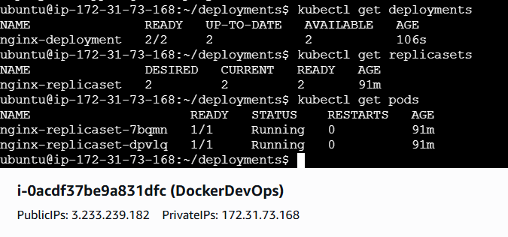
You’ll notice:
- Kubernetes created a ReplicaSet automatically
- That ReplicaSet created 2 Pods
- This is the standard production pattern
So while you don’t see a ReplicaSet in your YAML, it’s happening under the hood.

Part 2: Improve It for Rolling Updates (how changes are rolled)
Deployment Update Strategies:
a. RollingUpdate (default)
- Pods are updated gradually with zero downtime.
- Uses maxUnavailable and maxSurge to control rollout speed.
Step 1: improve your file
nano nginx-deployment.yaml
With: strategy
strategy:
type: RollingUpdate
rollingUpdate:
maxSurge: 1
maxUnavailable: 0
Update the spec to include:
apiVersion: apps/v1
kind: Deployment
metadata:
name: nginx-deployment
labels:
app: nginx
spec:
replicas: 2
selector:
matchLabels:
app: nginx
strategy:
type: RollingUpdate
rollingUpdate:
maxSurge: 1
maxUnavailable: 0
template:
metadata:
labels:
app: nginx
spec:
containers:
- name: nginx
image: nginx:1.21.1
ports:
- containerPort: 80
This tells Kubernetes:
- maxSurge: 1 → allow 1 extra Pod during updates
- maxUnavailable: 0 → ensure no downtime
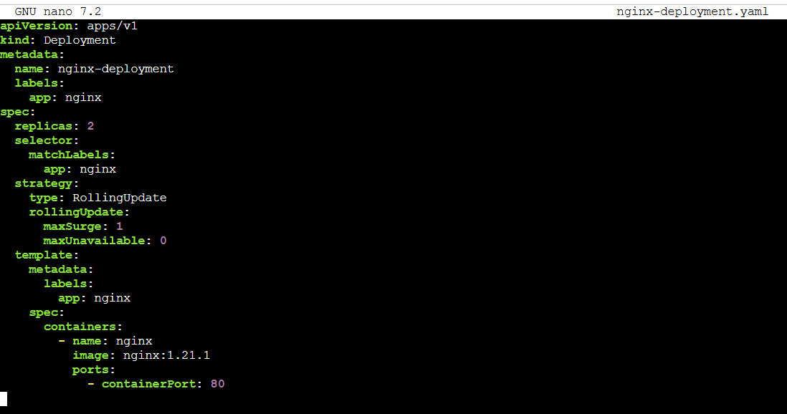
Reapply it:
kubectl apply -f nginx-deployment.yaml
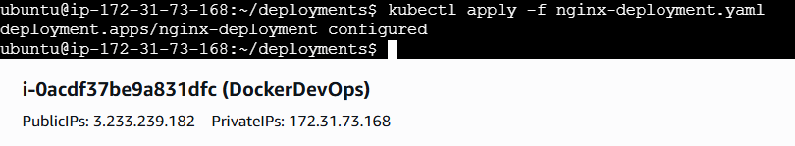
b. Recreate
- Deletes all old Pods first, then creates new ones.
- Causes downtime during the transition.
strategy:
type: Recreate
Use when: App can't run multiple versions at once (e.g., shared DB).

Part 3: Demo a Rolling Update
Let’s simulate deploying a new version of our app.
kubectl set image deployment/nginx-deployment nginx=nginx:1.23.1
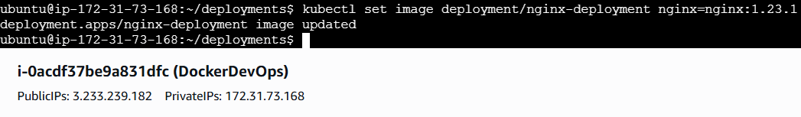
Watch the rollout:
kubectl rollout status deployment/nginx-deployment
What happens:
- A new ReplicaSet is created
- Pods are updated one by one
- No downtime occurs due to the rolling strategy
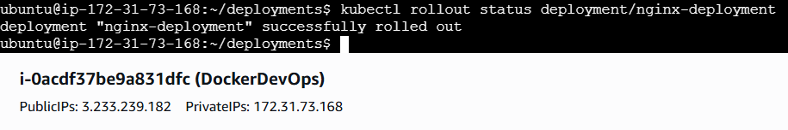
Check the status:
kubectl get pods
kubectl get replicasets
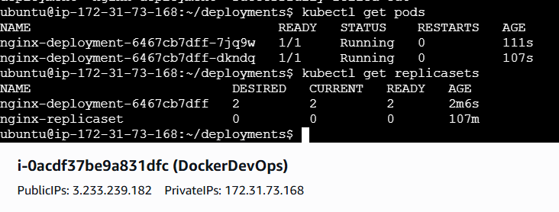

Part 4: Roll Back the Update
What if this version was buggy?
Just undo it:
kubectl rollout undo deployment/nginx-deployment
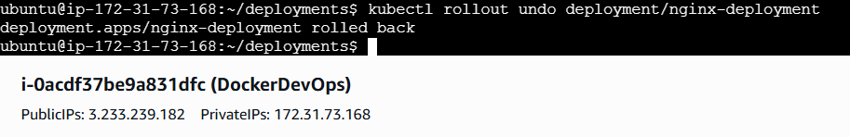
Verify rollback:
kubectl get pods
kubectl rollout history deployment/nginx-deployment
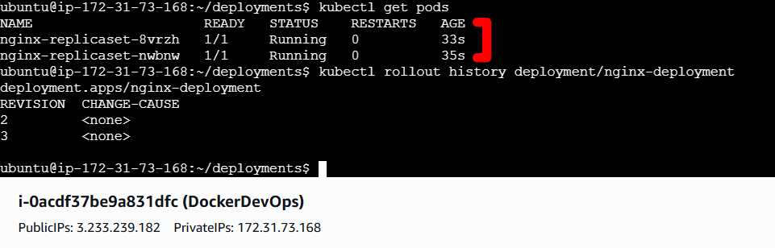
Kubernetes brings you back to the previous stable version. This is version control for your infrastructure.

Part 5: Scale with a Single Command
Want 5 replicas?
kubectl scale deployment nginx-deployment --replicas=5
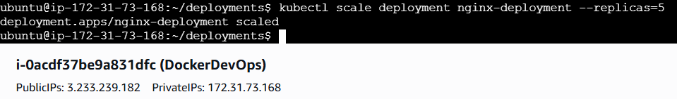
Verify:
kubectl get pods
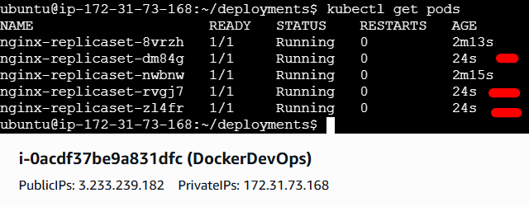
Scale down to 2 again:
kubectl scale deployment nginx-deployment --replicas=2
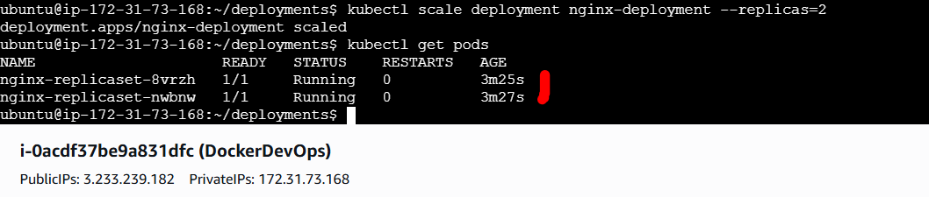

Wrap-Up: What Did You Learn?
- Deployments are the standard for running production apps
- They manage ReplicaSets behind the scenes
- They support:
  - Rolling updates to upgrade apps with no downtime
  - Rollbacks if something goes wrong
  - Scaling with a single command
In one YAML file, you're getting a resilient, self-healing, version-controlled deployment system — that’s why we use Deployments in production, not Pods or ReplicaSets alone.

Guided Lab 04: Auto-Scaling
Real-World Pain Running Containers
- Containers are tied to a single host
- No built-in self-healing
- No Production Deployment/rollback mechanism
- No horizontal scaling (Auto Scaling)
- No load balancing, service discovery, stable networking, decouples frontend and backend, external access
- Lack of Enterprise-Grade Features

Why Auto Scaling Matters
Imagine your app starts getting a spike in traffic — hundreds or thousands of users hitting it at once at 2:13 AM. You don’t want to scale it manually, right?
Kubernetes should add it—without you. And when traffic is low, it should shrink back pods to save money. That’s **auto-scaling.*”
You also don’t want to keep checking if all Pods are running.
Auto-healing: replace failed Pods to keep the desired count. Auto-scaling: change the desired count based on load (up and down).
Together, they keep your app both reliable and right-sized.”
Kubernetes can automatically scale your app up (or down) and automatically heal failed Pods — without you doing anything.
Let’s see it in action.

Step 1: Set Up Your Lab Directory
cd ~/k8s-labs
mkdir -p autoscaling
cd autoscaling
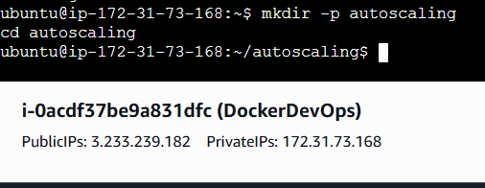

Part 1: Auto-Healing – Built-in by Design
Step 1: Use a basic Deployment again
Create a file:
touch autohealing-deployment.yaml
vi autohealing-deployment.yaml
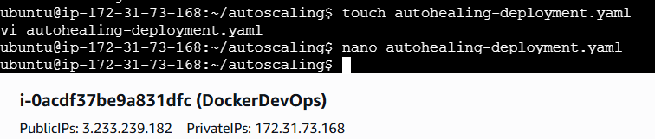
Paste this:
apiVersion: apps/v1
kind: Deployment
metadata:
name: demo-autohealing
labels:
app: autoheal
spec:
replicas: 2
selector:
matchLabels:
app: autoheal
template:
metadata:
labels:
app: autoheal
spec:
containers:
- name: nginx
image: nginx
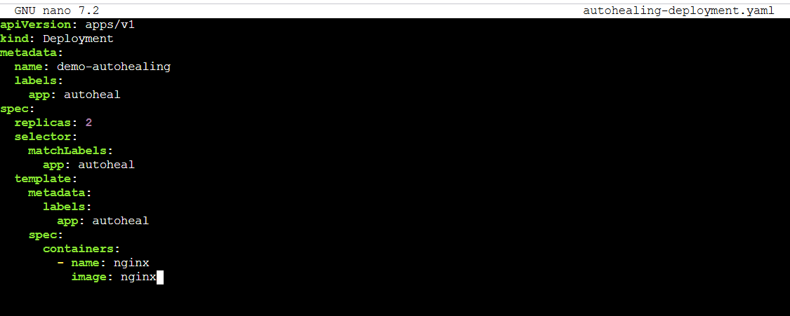
Apply it:
kubectl apply -f autohealing-deployment.yaml
kubectl get pods
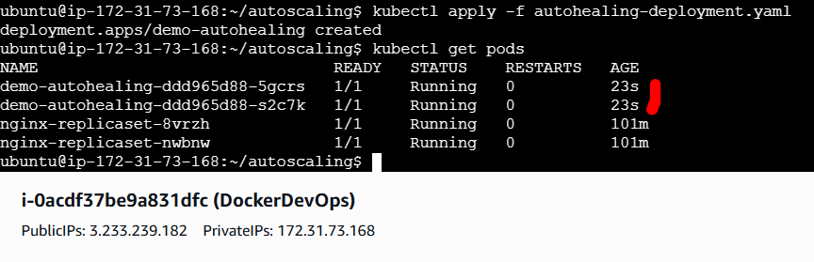
Step 2: Simulate a failure
Delete a Pod:
kubectl delete pod <name-of-any-pod>
Watch what happens:
kubectl get pods
Kubernetes automatically replaces the deleted Pod to maintain the desired number of replicas — that’s auto-healing, and it’s enabled by default via Deployments and ReplicaSets.
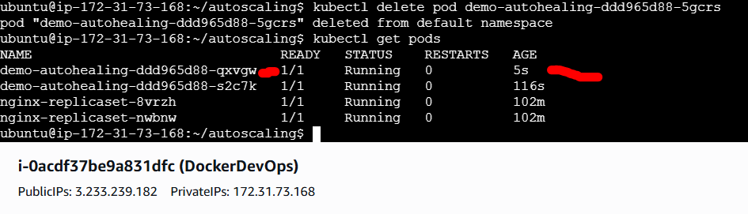

Part 2: Auto-Scaling with Horizontal Pod Autoscaler (HPA)
What is Horizontal Pod Autoscaler (HPA)?
A Horizontal Pod Autoscaler (HPA) is a Kubernetes feature that automatically adjusts the number of pods in a deployment, replica set, or stateful set to match the current workload.
This is where Kubernetes will scale your Pods based on CPU usage, Memory, custom/external metrics.
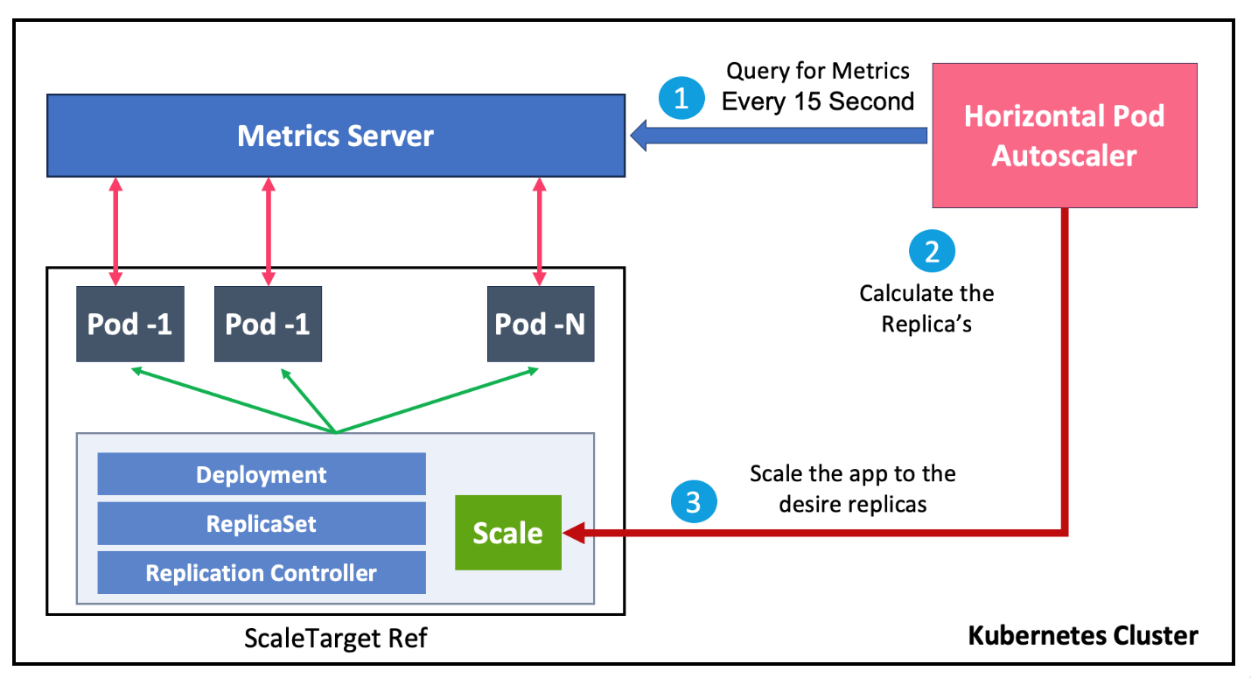
We’ll simulate it with a special image that generates CPU load.
Step 1: Create the file
touch hpa-deployment.yaml
nano hpa-deployment.yaml
Paste this:
apiVersion: apps/v1
kind: Deployment
metadata:
name: nginx-deployment
labels:
app: nginx
spec:
replicas: 2
selector:
matchLabels:
app: nginx
strategy:
type: RollingUpdate
rollingUpdate:
maxSurge: 1
maxUnavailable: 0
template:
metadata:
labels:
app: nginx
spec:
containers:
- name: nginx
image: nginx:1.21.1
ports:
- containerPort: 80
resources:
requests:
cpu: "100m"
limits:
cpu: "200m"
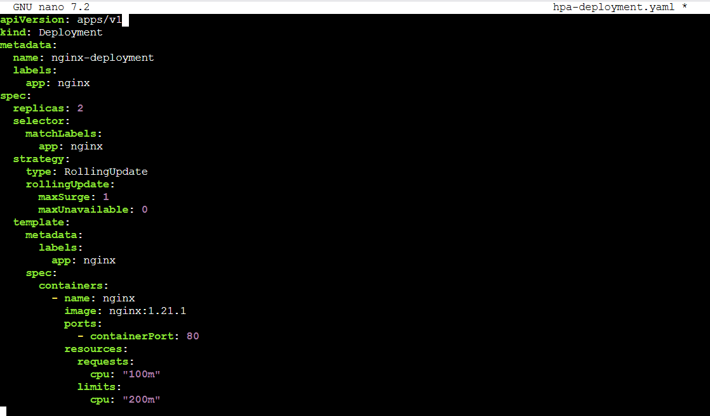
How it works together:
- requests = guaranteed resource (used by scheduler to place pod)
- limits = maximum allowed usage (enforced at runtime)
Example behavior:
- Pod can use CPU between 100m and 200m.
- If node is under pressure, Kubernetes ensures pods at least get their requested CPU.
- If pod tries to burst beyond 200m, it will be throttled.
Apply it:
kubectl apply -f hpa-deployment.yaml
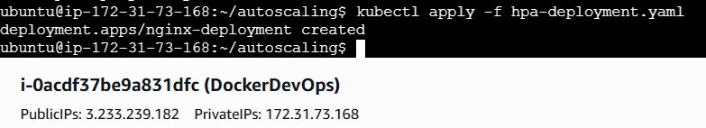

Step 2: Enable the autoscaler
Enable metrics-server for MiniKube
You’ll need the metrics server running in your cluster. If not installed, follow this (for Minikube):
minikube addons enable metrics-server
Enable metrics-server for Kind
kubectl apply -f https://github.com/kubernetes-sigs/metrics-server/releases/latest/download/components.yaml
kubectl patch deployment metrics-server -n kube-system \
--type='json' -p='[{"op": "add", "path": "/spec/template/spec/containers/0/args/-", "value":"--kubelet-insecure-tls"}]'
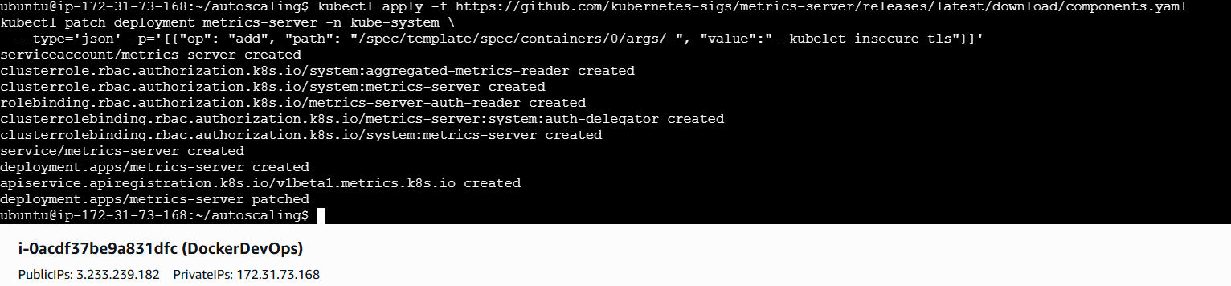
Verify Metrics Server is running
kubectl get deployment metrics-server -n kube-system
Make sure the READY column shows 1/1.
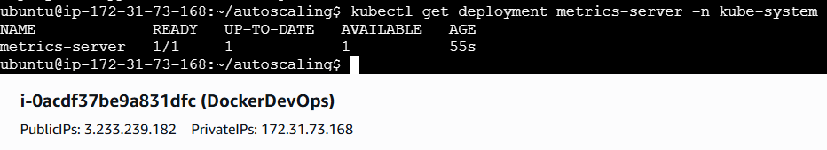
Now create the HPA:
Option 1: Imperative Command (Quick & Ad-Hoc)
kubectl autoscale deployment nginx-deployment --cpu-percent=50 --min=2 --max=5
When to use:
- Quick testing or debugging
- Live demos or labs
- Ad-hoc changes in dev environments

Option 2: Declarative YAML (Production Best Practice)
Step 1: Create the YAML file
touch hpa-nginx.yaml
nano hpa-nginx.yaml
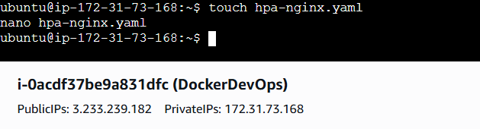
Paste this:
apiVersion: autoscaling/v2
kind: HorizontalPodAutoscaler
metadata:
name: nginx-hpa
spec:
scaleTargetRef:
apiVersion: apps/v1
kind: Deployment
name: nginx-deployment
minReplicas: 2
maxReplicas: 5
metrics:
- type: Resource
resource:
name: cpu
target:
type: Utilization
averageUtilization: 50
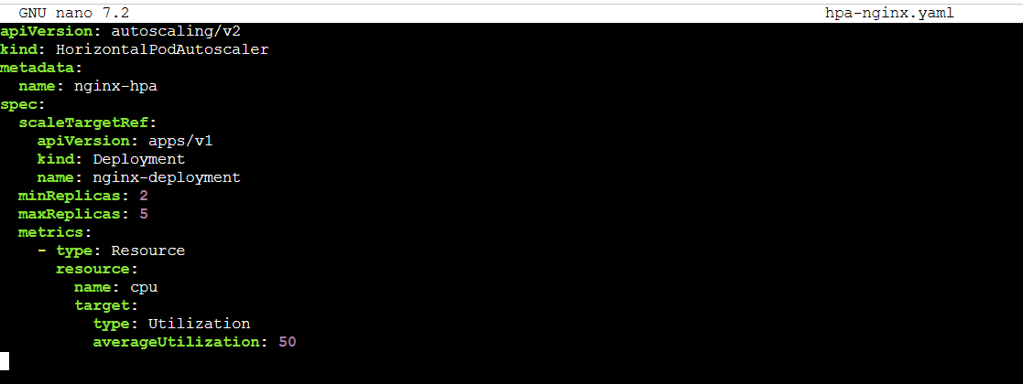
Apply it:
kubectl apply -f hpa-nginx.yaml
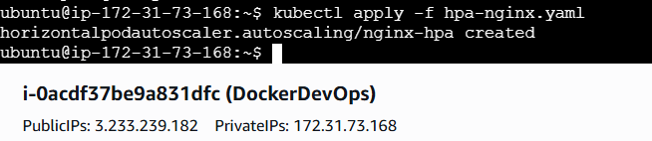
Check status:
kubectl get hpa
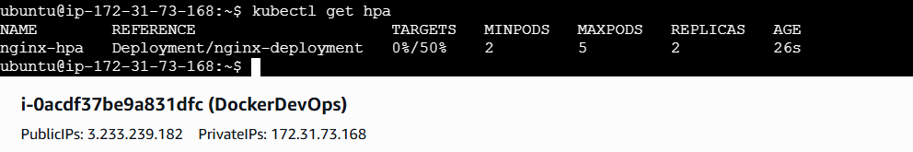
kubectl describe hpa nginx-hpa
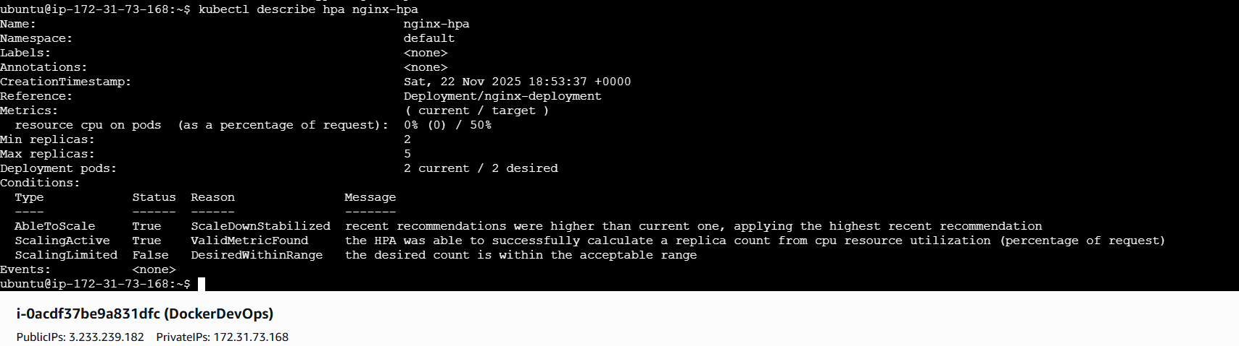
kubectl delete hpa nginx-hpa
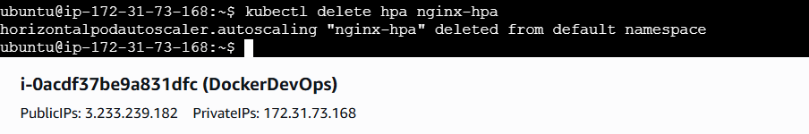

Step 3: (Optional) Manually Generate CPU Load
To simulate high CPU load and trigger scaling:
kubectl exec -it nginx-deployment-865d9545dc- xk6r4 -- /bin/sh
# Inside the container:
yes > /dev/null

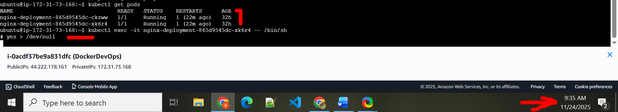

Then check again:
kubectl get hpa
kubectl get pods
You’ll see Kubernetes automatically increasing the number of Pods based on CPU stress.
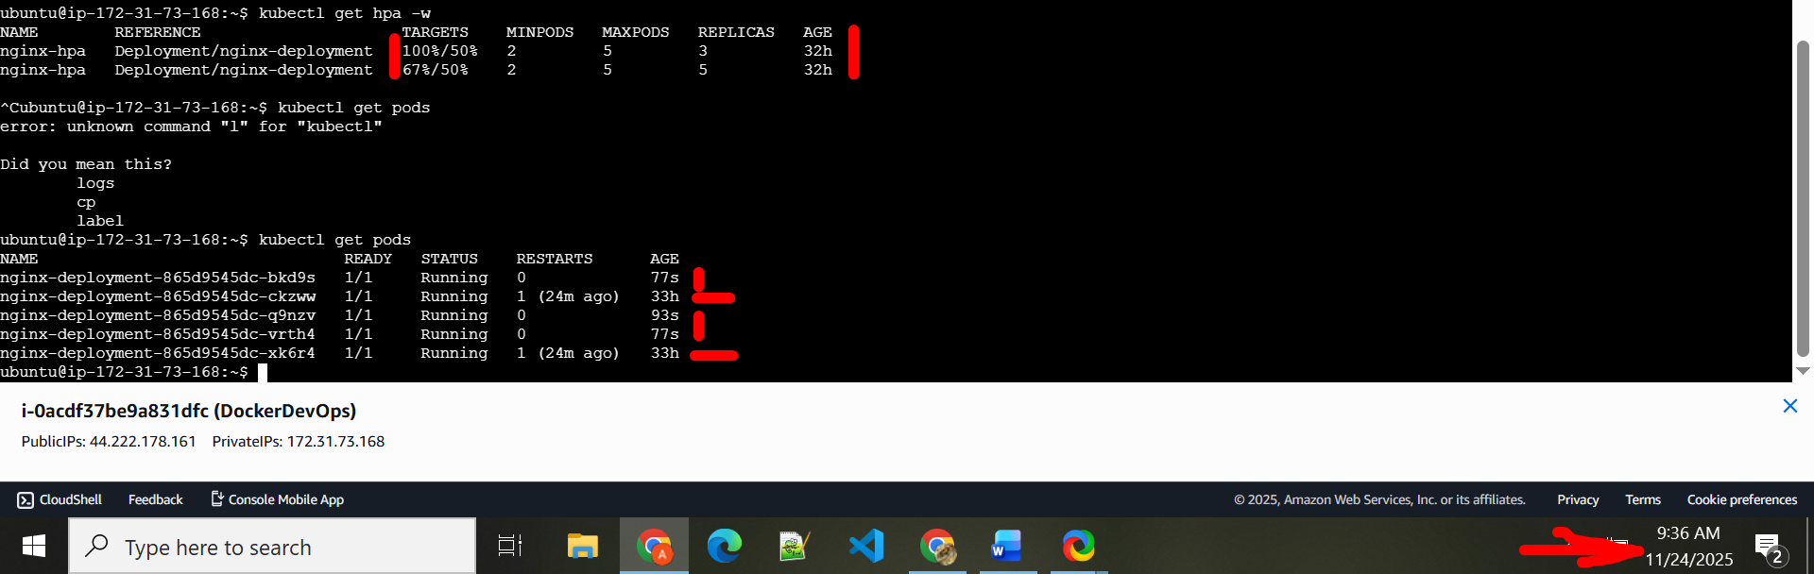

Wrap-Up: What Did You Learn?
- Auto-Healing is built into Deployments via ReplicaSets
- Kubernetes replaces failed Pods without any manual action
- Horizontal Pod Autoscaler (HPA) lets you define CPU-based rules to auto-scale Pods
- You can scale between a minimum and maximum range — automatically
- All of this is done with zero human intervention

Guided Lab 05 — Kubernetes Health Probes (Readiness)
Scope: Only readiness. Default namespace. No Services yet. We’ll prove why readiness matters by watching how it gates rollouts and Pod availability—the practical “why” before we learn how traffic is routed.

1) Introduction
You already have a running Deployment
You’ve defined:
- Replicas: 2 — Kubernetes keeps two Pods running.
- RollingUpdate strategy — safe, graceful upgrades.
- HPA (Auto Scaling): requests/limits — each Pod gets fair CPU.
So far, so good. The Deployment looks clean.
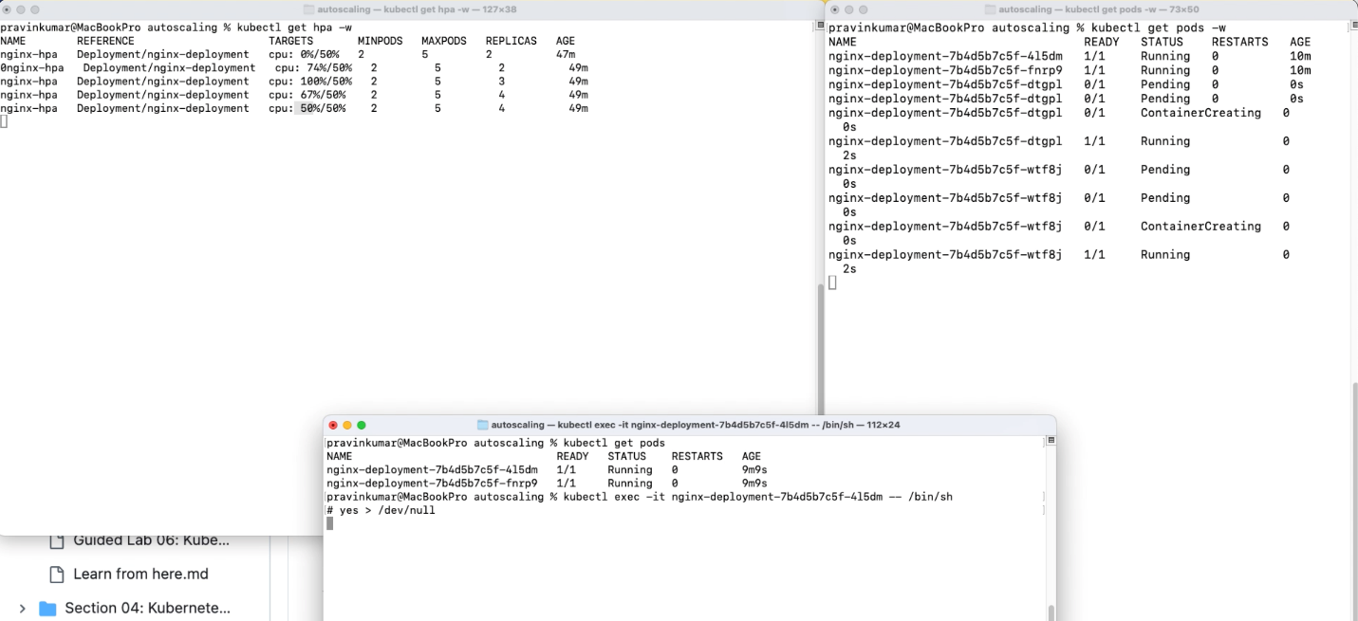
But here’s the big gap: how does Kubernetes know when your container is actually ready to serve traffic?

The Hidden Problem
“Running” is not the same as “Ready.”
Imagine this:
- The container process starts.
- But NGINX is still booting, parsing config, warming cache, or waiting on a dependency.
- If Kubernetes assumes “Pod is running ⇒ good to go,” users may hit timeouts or errors.
We need a way to say: “Don’t send me work until I’m truly ready.”
Readiness Probe: Determines if a container is ready to accept traffic.
Liveness Probe: Checks if a container is still running correctly. If it fails, the container is restarted.
Startup Probe: Verifies that the application within a container has started successfully.

What Readiness Probes Do
A readinessProbe tells Kubernetes exactly when a Pod can reliably take requests.
- Until the probe succeeds, Ready = False.
- During that time, the Pod does not count as available for rollouts and (later when we add Services) is excluded from endpoints.
- When the probe passes, Ready = True and Kubernetes treats it as available.
In rolling updates, this prevents the platform from swapping out old, healthy Pods for new Pods that are still warming up.

A Quick Example
readinessProbe:
httpGet:
path: /
port: 80
initialDelaySeconds: 5
periodSeconds: 10
- Wait 5s after container start.
- Then hit / on port 80 every 10s.
- Only after a 200 OK will Kubernetes mark the Pod Ready.

2) Step-by-Step Hands-On Setup
We’ll keep files tidy in a dedicated folder, working in the default namespace.
cd ~
mkdir -p ~/k8s-labs/health-probes-readiness
cd ~/k8s-labs/health-probes-readiness
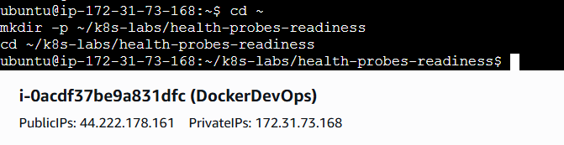
2.1 Baseline Deployment (no probes)
touch 00-nginx-deploy-baseline.yaml
nano 00-nginx-deploy-baseline.yaml
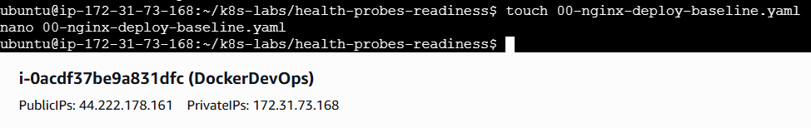
Paste:
apiVersion: apps/v1
kind: Deployment
metadata:
name: nginx-deployment
labels:
app: nginx
spec:
replicas: 2
selector:
matchLabels:
app: nginx
strategy:
type: RollingUpdate
rollingUpdate:
maxSurge: 1
maxUnavailable: 0
template:
metadata:
labels:
app: nginx
spec:
containers:
- name: nginx
image: nginx:1.21.1
ports:
- containerPort: 80
resources:
requests:
cpu: "100m"
limits:
cpu: "200m"
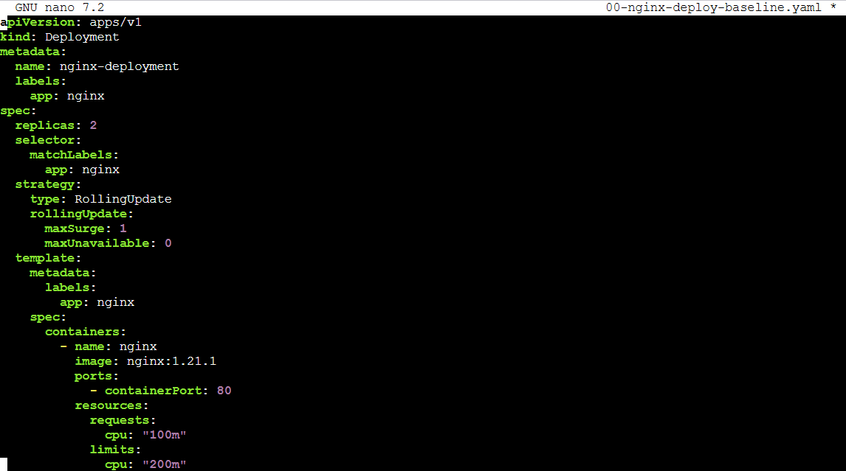
Apply and verify:
kubectl apply -f 00-nginx-deploy-baseline.yaml
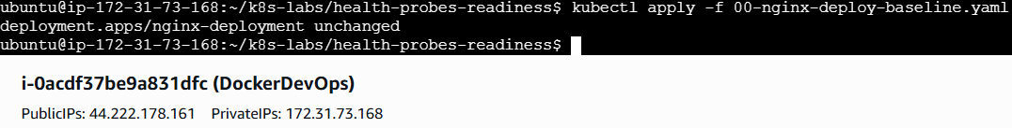
kubectl rollout status deployment/nginx-deployment
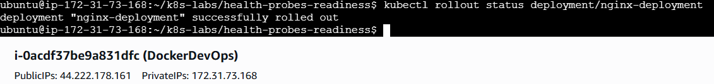
kubectl get pods -l app=nginx -o wide
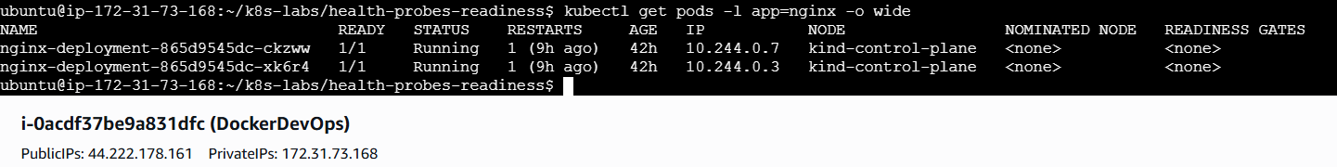
kubectl describe deploy nginx-deployment | sed -n '1,120p'
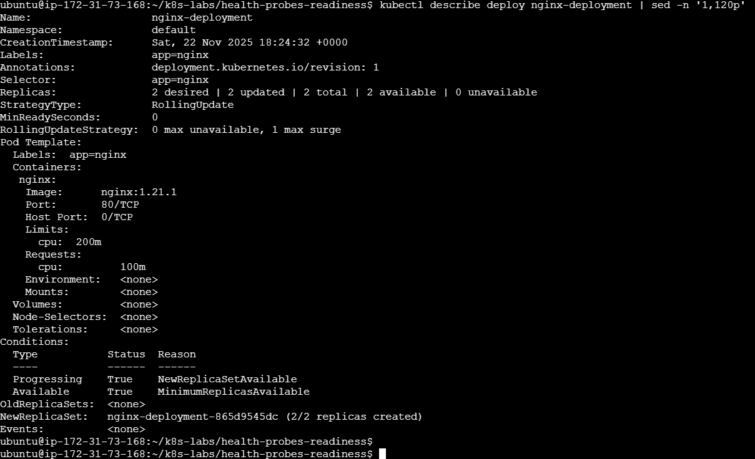
Why this baseline? It mirrors what you already have—no probes yet—so you can feel the difference once readiness is added.
Let’s recap: Two NGINX Pods running, clean rollout config, no health checks beyond “process is running.”

3) Add a Readiness Probe
Now we’ll teach Kubernetes when the Pod is actually ready.
touch 01-nginx-deploy-readiness.yaml
nano 01-nginx-deploy-readiness.yaml
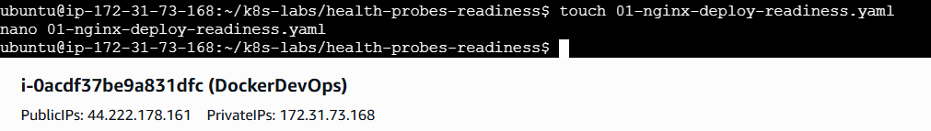
Paste:
apiVersion: apps/v1
kind: Deployment
metadata:
name: nginx-deployment
labels:
app: nginx
spec:
replicas: 2
selector:
matchLabels:
app: nginx
strategy:
type: RollingUpdate
rollingUpdate:
maxSurge: 1
maxUnavailable: 0
template:
metadata:
labels:
app: nginx
spec:
containers:
- name: nginx
image: nginx:1.21.1
ports:
- containerPort: 80
readinessProbe:
httpGet:
path: /
port: 80
# Tuning for quick feedback but avoiding false alarms
initialDelaySeconds: 2
periodSeconds: 5
timeoutSeconds: 1
failureThreshold: 3
successThreshold: 1
resources:
requests:
cpu: "100m"
limits:
cpu: "200m"
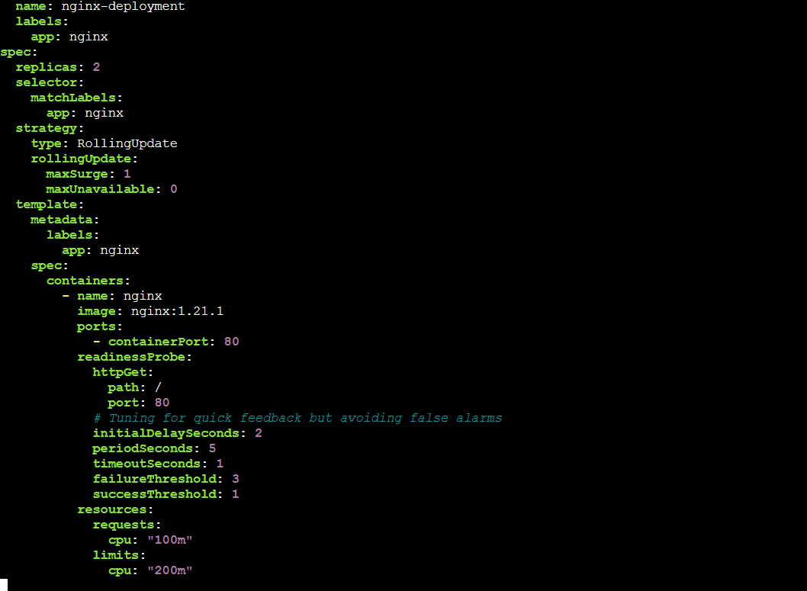
Apply and watch:
kubectl apply -f 01-nginx-deploy-readiness.yaml
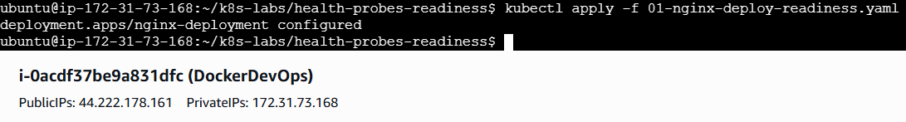
kubectl rollout status deployment/nginx-deployment
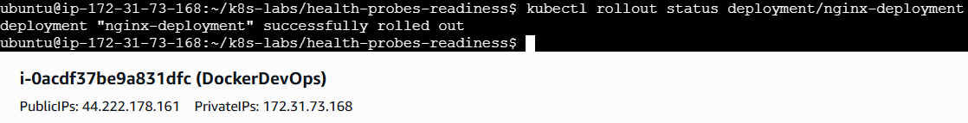
kubectl get pods -l app=nginx -w
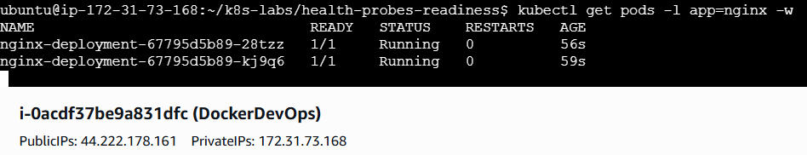
Inspect probe & conditions:
POD=$(kubectl get pod -l app=nginx -o jsonpath='{.items[0].metadata.name}')
kubectl describe pod "$POD" | sed -n '1,200p'
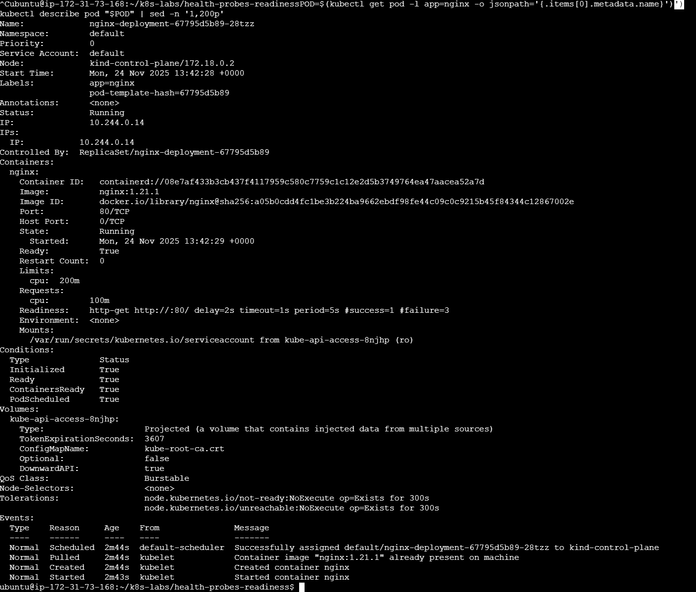
What changed:
- The Pod won’t be considered Ready until the probe passes.
- With maxUnavailable: 0, rollouts require a new Pod to be Ready before an old Pod is removed—your “zero-downtime” safety net.
Let’s recap: Readiness is now a first-class signal. Kubernetes won’t count a Pod as available until / responds successfully.

4) Feel Readiness by Breaking It (and Fixing It)
We’ll intentionally fail the probe by pointing it to a path that returns 404.
cp 01-nginx-deploy-readiness.yaml 02-nginx-readiness-broken.yaml
nano 02-nginx-readiness-broken.yaml
Change only the probe path:
readinessProbe:
httpGet:
path: /does-not-exist # break readiness on purpose
port: 80
initialDelaySeconds: 2
periodSeconds: 5
timeoutSeconds: 1
failureThreshold: 3
successThreshold: 1
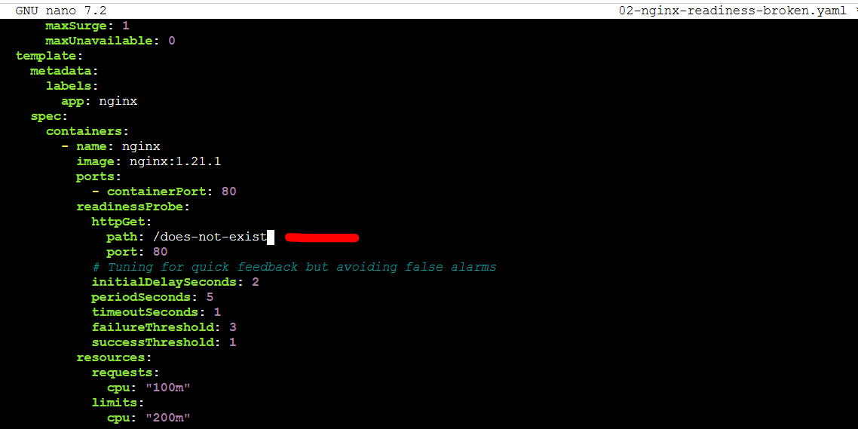
Apply and observe:
kubectl apply -f 02-nginx-readiness-broken.yaml
kubectl rollout status deployment/nginx-deployment --timeout=60s || true
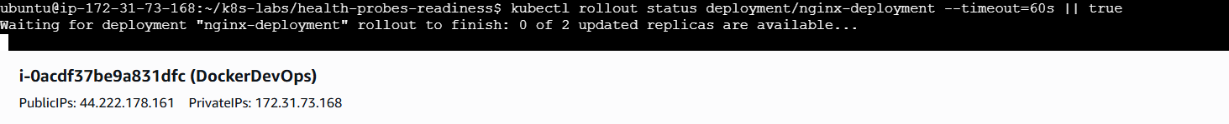
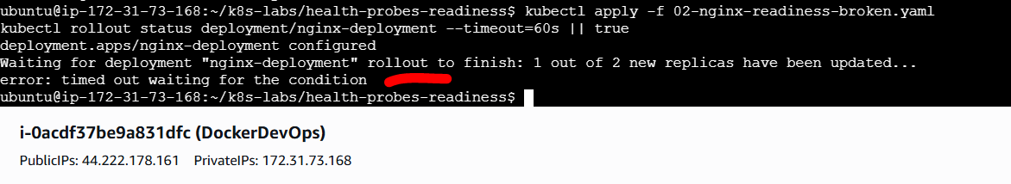
kubectl get pods -l app=nginx
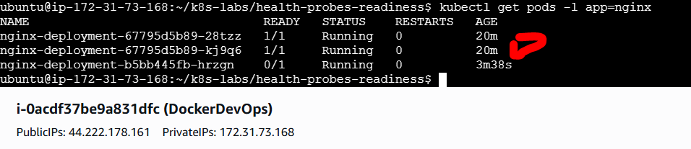
kubectl describe pod $(kubectl get pod -l app=nginx -o jsonpath='{.items[0].metadata.name}') | sed -n '1,200p'
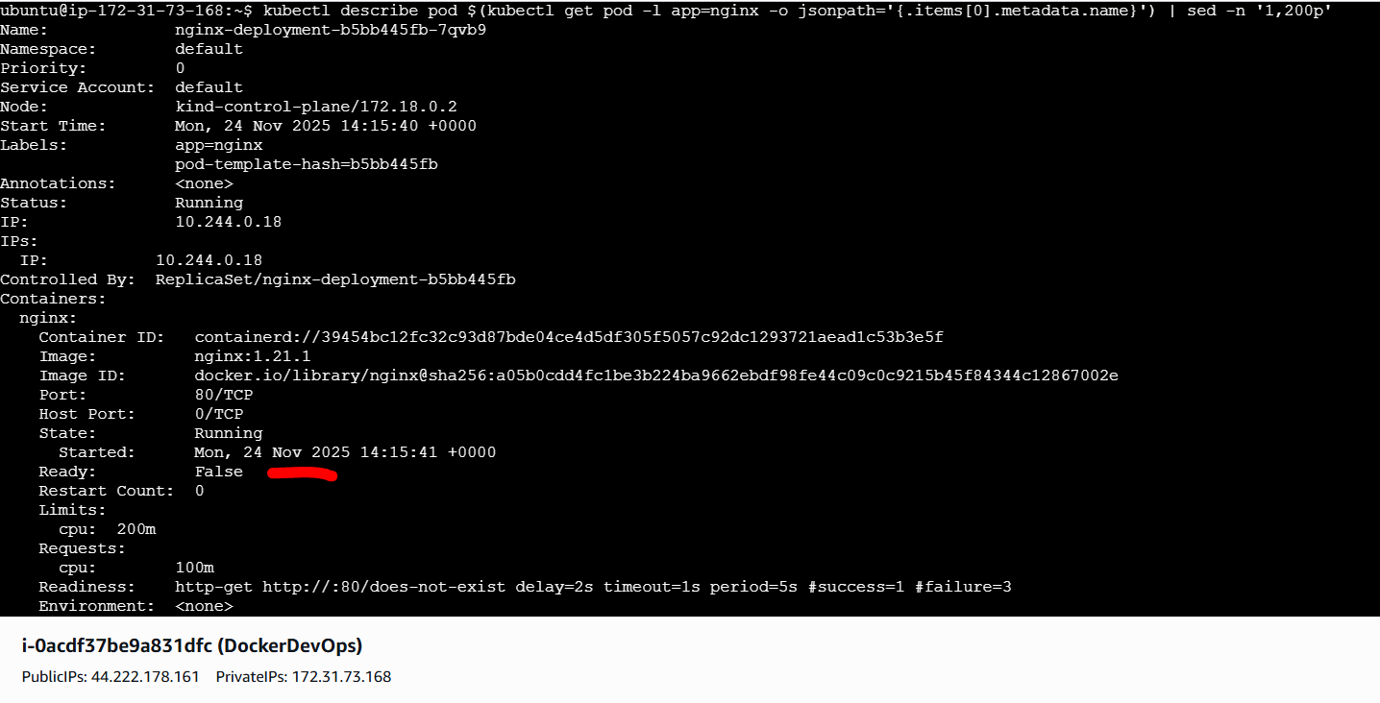

What you should see:
- Pod Conditions show Ready: False.
- The Deployment can struggle to complete a rollout (since new Pods never become Ready).
Now fix readiness:
cp 01-nginx-deploy-readiness.yaml 03-nginx-readiness-fixed.yaml
kubectl apply -f 03-nginx-readiness-fixed.yaml
kubectl rollout status deployment/nginx-deployment
kubectl get pods -l app=nginx
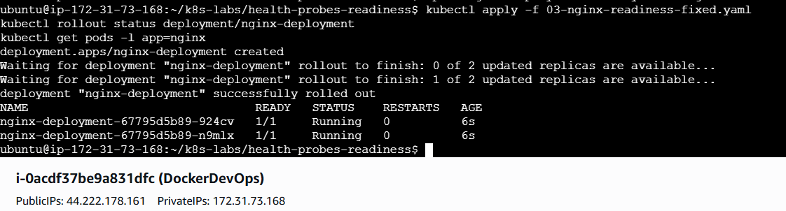
Let’s recap: You saw Pods stay NotReady when the probe fails, and the rollout won’t fully complete. Restoring a good probe returns Pods to Ready, and the rollout finishes cleanly.

5) See How Readiness Gates Rolling Updates
This is the real “why”: readiness prevents bad versions from replacing good ones.
- Start from the fixed readiness spec:
kubectl apply -f 03-nginx-readiness-fixed.yaml
kubectl rollout status deployment/nginx-deployment
kubectl get pods -l app=nginx
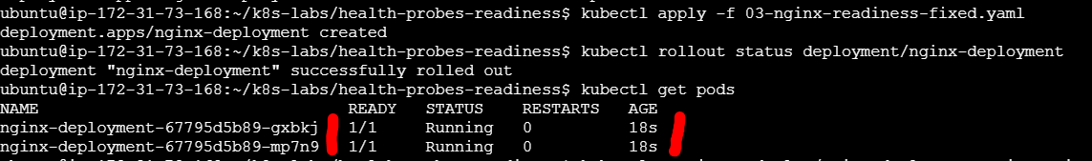
- Trigger an upgrade to a new image (good case):
kubectl set image deploy/nginx-deployment nginx=nginx:1.21.3
kubectl rollout status deploy/nginx-deployment
kubectl get rs -l app=nginx
kubectl get pods -l app=nginx -o wide
You’ll see a new ReplicaSet created; new Pods become Ready, then old Pods are scaled down—no downtime.
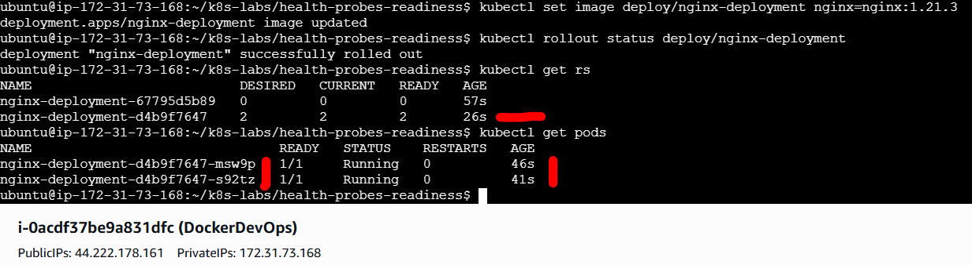
- Rollback the image and break readiness (to see rollout protection):
kubectl set image deploy/nginx-deployment nginx=nginx:1.21.4
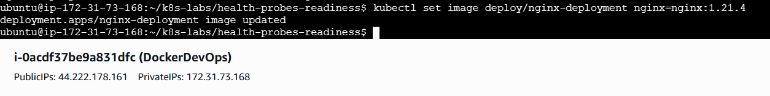
# Now make readiness fail on the template so new pods never become Ready
cat > 04-readiness-broken-patch.yaml <<'EOF'
spec:
template:
spec:
containers:
- name: nginx
image: nginx:1.21.4
readinessProbe:
httpGet:
path: /does-not-exist
port: 80
initialDelaySeconds: 2
periodSeconds: 5
timeoutSeconds: 1
failureThreshold: 3
successThreshold: 1
EOF
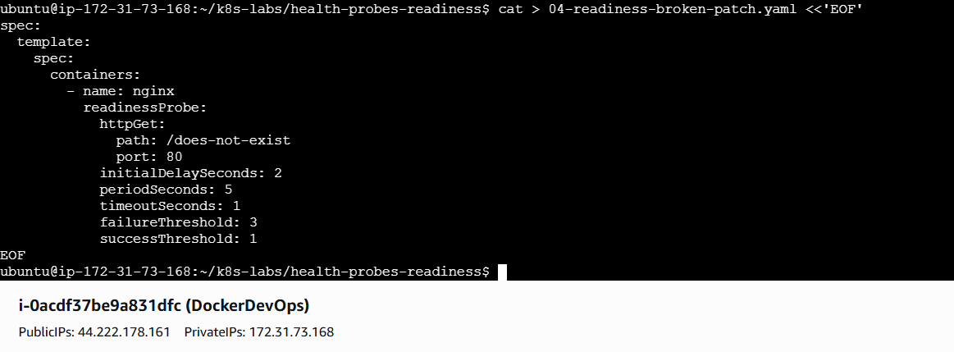
kubectl patch deploy nginx-deployment --type merge --patch-file 04-readiness-broken-patch.yaml
kubectl rollout status deploy/nginx-deployment --timeout=60s || true
kubectl get pods -l app=nginx
kubectl describe deploy nginx-deployment | sed -n '1,200p'
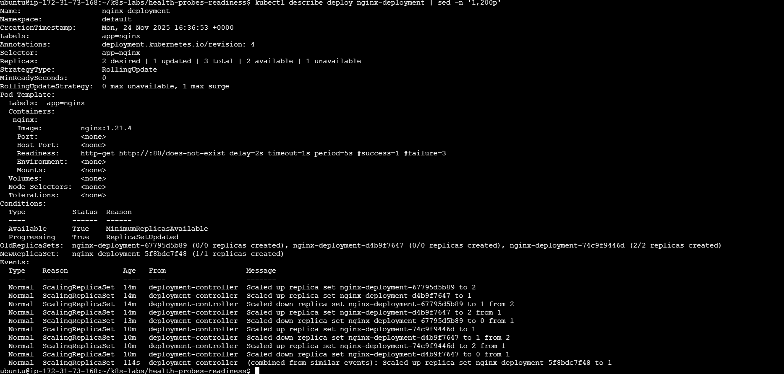
The rollout should hang or stay in progress, because new Pods never reach Ready. Fix it:
kubectl apply -f 03-nginx-readiness-fixed.yaml
kubectl rollout status deploy/nginx-deployment
Let’s recap: Readiness + maxUnavailable: 0 = safe rollouts. New Pods must prove they’re Ready before old Pods are retired.
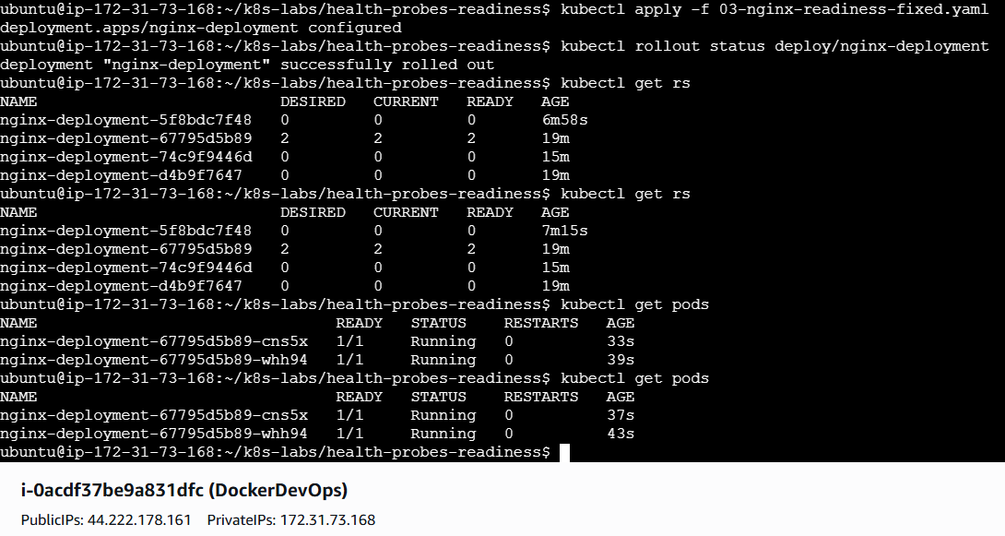

6) Practical Tuning Notes (just enough for now)
- HTTP GET to a lightweight path (/healthz or /) is perfect for web apps.
- initialDelaySeconds covers startup warmup; don’t make it so long that you hide real issues.
- periodSeconds/timeoutSeconds: keep checks cheap and frequent; 1s timeouts are common.
- failureThreshold: small numbers fail fast; larger values give apps a chance to recover during brief hiccups.
- Rollouts: with maxUnavailable: 0, readiness directly enforces zero-downtime behavior.

7) Clean Up (optional)
# Keep it for the next lab, or remove it now:
# kubectl delete deploy nginx-deployment
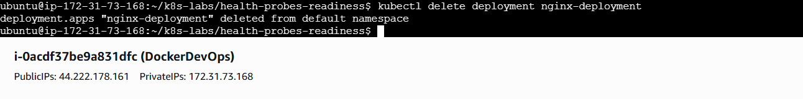

Wrap-Up — What Did You Learn?
- Readiness answers: “Can this Pod reliably take requests?” Until it’s true, Ready = False.
- With readiness in place, Kubernetes:
  - Excludes NotReady Pods from availability (and later from Service endpoints).
  - Protects rolling updates—new Pods must become Ready before old Pods are removed (thanks to maxUnavailable: 0).
- You:
  - Added a readiness probe.
  - Broke it to see NotReady behavior and rollout stalling.
  - Fixed it to complete the rollout cleanly.
  - Learned sane defaults and what each knob does.
Next: when we understand health probes Liveness.

Guided Lab 06 — Kubernetes Health Probes (Liveness)
“What happens after it’s been running for a while? Who makes sure it’s still healthy?”
That’s where Liveness Probes come in. Let’s understand it.

1) Introduction

You’ve Built a Smart, Reliable Deployment
So far, your Deployment does a lot right:
- Replicas (2) → Always keeps two Pods alive.
- Resources → Prevents CPU starvation.
- Rolling updates → No downtime during upgrades.
- Readiness Probe → Ensures new Pods only get traffic when they’re ready.
You’ve taught Kubernetes how to wait patiently before trusting a Pod. But once traffic starts flowing, a new question arises…

The Hidden Problem: What If a Running Pod “Hangs”?
Imagine this real-world story:
Your nginx Pods have been serving traffic smoothly for hours. Then suddenly — a bug, a memory leak, or a network glitch makes one container freeze.
- The process is still running in memory.
- Kubernetes sees it as “healthy” (because the container didn’t crash).
- But in reality, it’s not responding to requests anymore.
From Kubernetes’ point of view:
“Container process is alive — everything’s fine.” From a user’s point of view: “Half the site is timing out!”
So now, you have a Pod that’s running, but broken. And no one restarts it — because Kubernetes doesn’t know it’s sick.

This Is Where the Liveness Probe Saves You
A Liveness Probe teaches Kubernetes how to detect and fix stuck containers.
You tell it:
“Check this endpoint or command regularly. If it stops responding, restart the container automatically.”

How It Works
Let’s say you add this probe to your container:
livenessProbe:
httpGet:
path: /
port: 80
initialDelaySeconds: 10
periodSeconds: 20
Here’s what Kubernetes does behind the scenes:
- Wait 10 seconds after startup (to let the app initialize).
- Then, every 20 seconds, send an HTTP GET request to / on port 80.
- If it fails several times in a row (default: 3), Kubernetes says:
“This container isn’t healthy — restart it.”
It’s a simple but powerful self-healing loop.

Liveness vs. Readiness — Subtle but Crucial Difference
Feature | Purpose | When It Triggers
Readiness Probe | Checks if the app is ready to handle traffic | Before routing traffic
Liveness Probe | Checks if the app is still alive and responsive | After it’s been running
Think of it like this:
- Readiness = “I’m ready to serve customers.”
- Liveness = “I’m still serving customers properly.”

2) Step-by-Step Hands-On Setup
We’ll keep files tidy in a dedicated folder, working in the default namespace.
cd ~
mkdir -p ~/k8s-labs/health-probes-liveness
cd ~/k8s-labs/health-probes-liveness
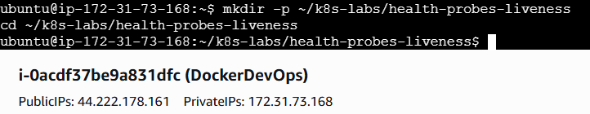
2.1 Baseline Deployment (no probes)
touch 00-nginx-deploy-baseline.yaml
nano 00-nginx-deploy-baseline.yaml
Paste:
apiVersion: apps/v1
kind: Deployment
metadata:
name: nginx-deployment
labels:
app: nginx
spec:
replicas: 2
selector:
matchLabels:
app: nginx
strategy:
type: RollingUpdate
rollingUpdate:
maxSurge: 1
maxUnavailable: 0
template:
metadata:
labels:
app: nginx
spec:
containers:
- name: nginx
image: nginx:1.21.1
ports:
- containerPort: 80
resources:
requests:
cpu: "100m"
limits:
cpu: "200m"
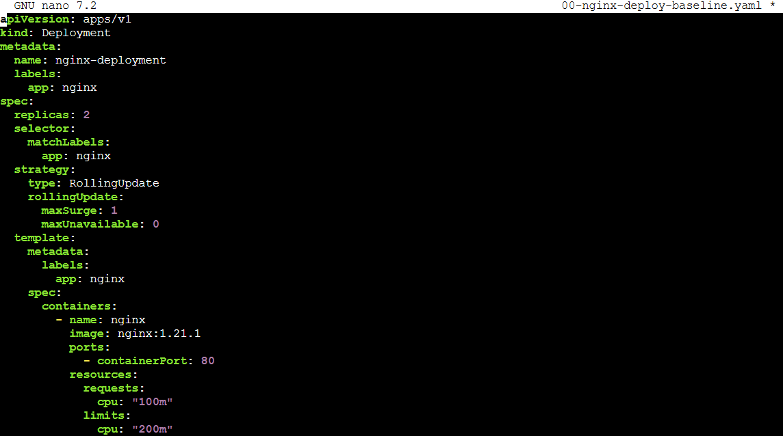
Apply and verify:
kubectl apply -f 00-nginx-deploy-baseline.yaml
kubectl rollout status deployment/nginx-deployment
kubectl get pods -l app=nginx -o wide
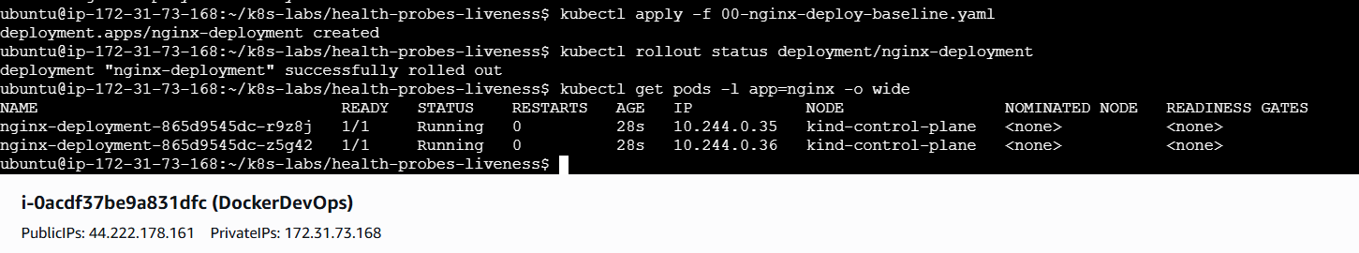
kubectl describe deploy nginx-deployment | sed -n '1,160p'
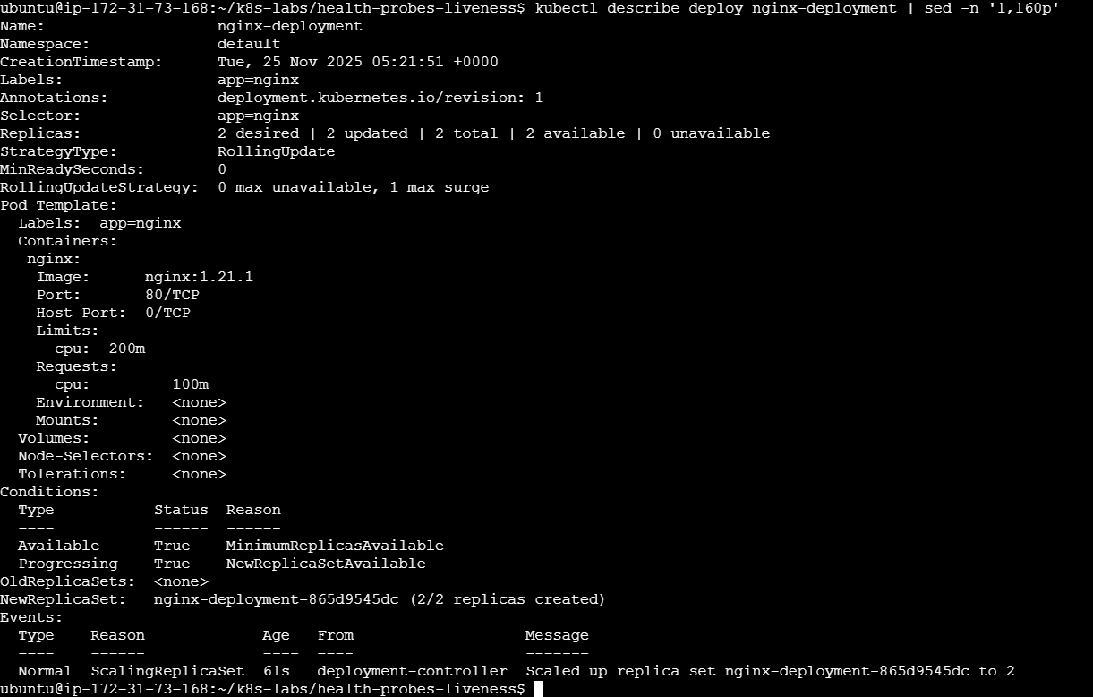
Why this baseline? It matches your earlier deployments with no probes—so the effect of liveness will be obvious.
Let’s recap: Two NGINX Pods are running cleanly. No health checks yet.

3) Add a Liveness Probe
Now we’ll teach Kubernetes when to restart the container.
touch 01-nginx-deploy-liveness.yaml
nano 01-nginx-deploy-liveness.yaml
Paste:
apiVersion: apps/v1
kind: Deployment
metadata:
name: nginx-deployment
labels:
app: nginx
spec:
replicas: 2
selector:
matchLabels:
app: nginx
strategy:
type: RollingUpdate
rollingUpdate:
maxSurge: 1
maxUnavailable: 0
template:
metadata:
labels:
app: nginx
spec:
containers:
- name: nginx
image: nginx:1.21.1
ports:
- containerPort: 80
livenessProbe:
httpGet:
path: /
port: 80
# Give nginx a small grace period, then verify regularly
initialDelaySeconds: 10
periodSeconds: 10
timeoutSeconds: 1
failureThreshold: 3
resources:
requests:
cpu: "100m"
limits:
cpu: "200m"
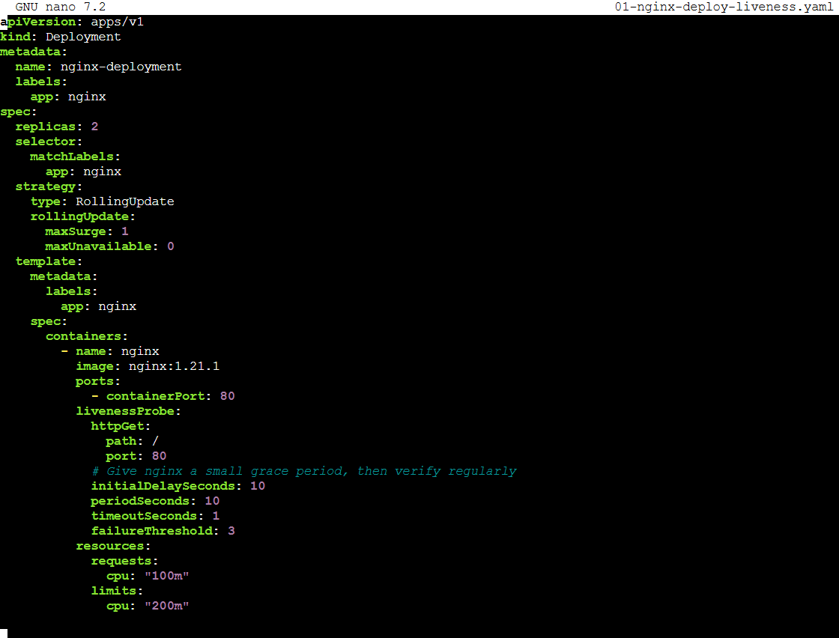
Apply and watch:
kubectl apply -f 01-nginx-deploy-liveness.yaml
kubectl rollout status deployment/nginx-deployment
kubectl get pods -l app=nginx -w
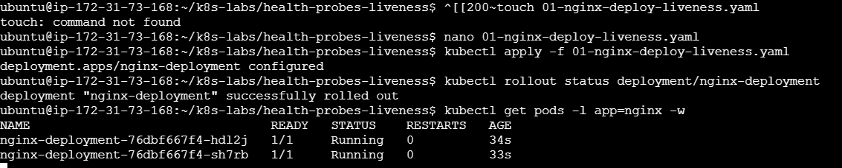
Inspect one Pod to see the probe and events:
POD=$(kubectl get pod -l app=nginx -o jsonpath='{.items[0].metadata.name}')
kubectl describe pod "$POD" | sed -n '1,240p'
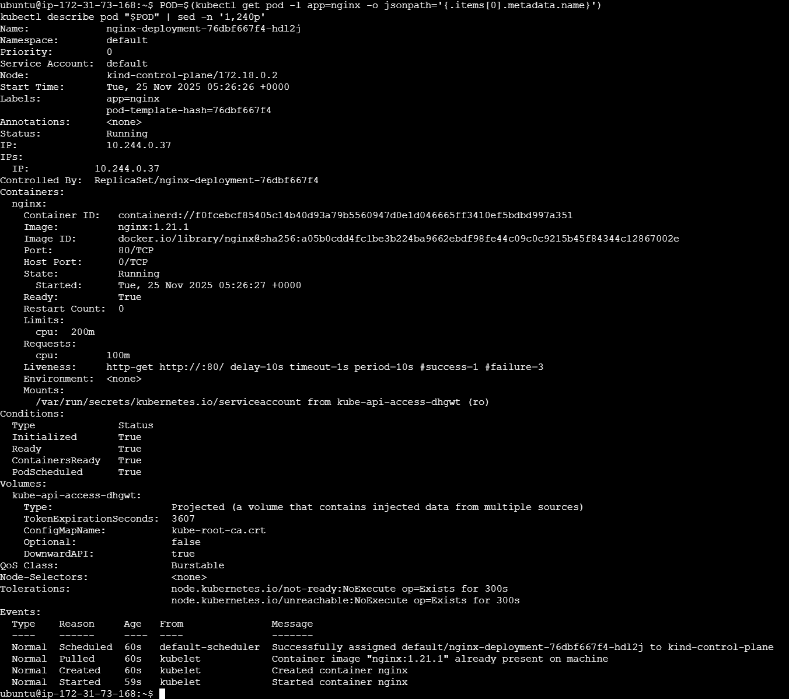
What changed:
- Kubernetes will periodically verify NGINX responds on /.
- Sustained failures will restart the container in-place (Pod remains).
Let’s recap: Liveness is now active. It won’t affect traffic directly; it impacts process survival by restarting wedged containers.

4) Verification — Intentionally Trigger a Liveness Restart
To see liveness in action, we’ll make the probe consistently fail by pointing it to an invalid path (NGINX returns 404 → failure).
cp 01-nginx-deploy-liveness.yaml 02-nginx-liveness-broken.yaml
nano 02-nginx-liveness-broken.yaml
Change only the liveness path:
livenessProbe:
httpGet:
path: /does-not-exist # force failures (404)
port: 80
initialDelaySeconds: 5
periodSeconds: 5
timeoutSeconds: 1
failureThreshold: 3
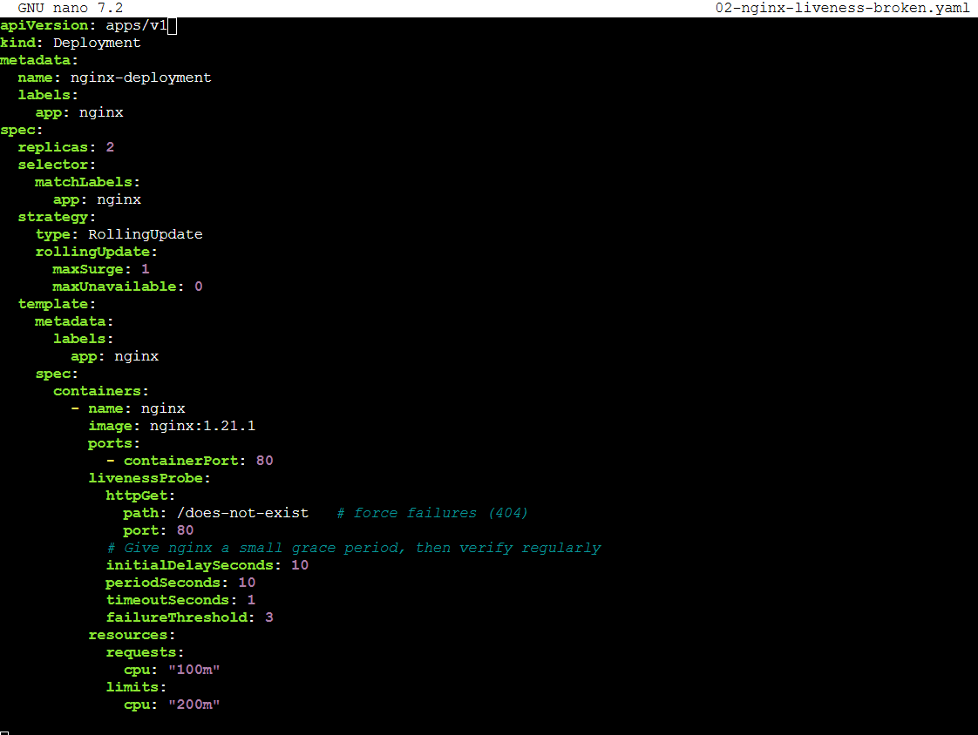
Apply and watch restarts:
kubectl apply -f 02-nginx-liveness-broken.yaml
kubectl rollout status deployment/nginx-deployment
kubectl get pods -l app=nginx -w
After roughly initialDelay + period × failureThreshold (≈ 5 + 5×3 = 20s), you should see RESTARTS increment:
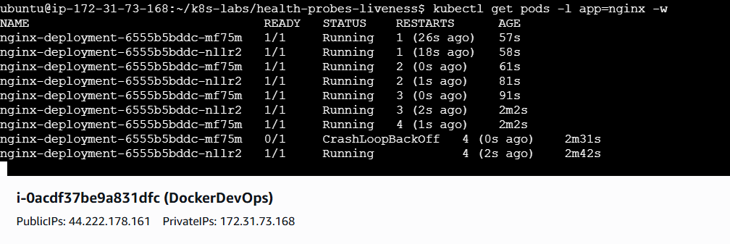
kubectl get pods -l app=nginx
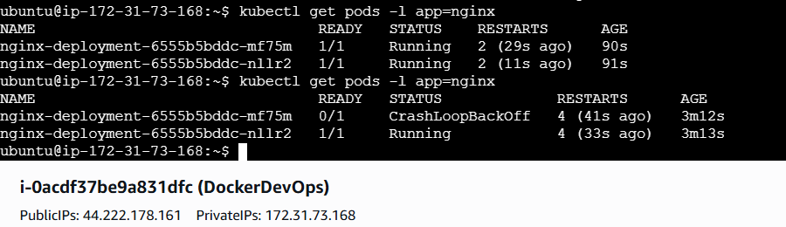 kubectl describe pod $(kubectl get pod -l app=nginx -o jsonpath='{.items[0].metadata.name}') | sed -n '1,240p'
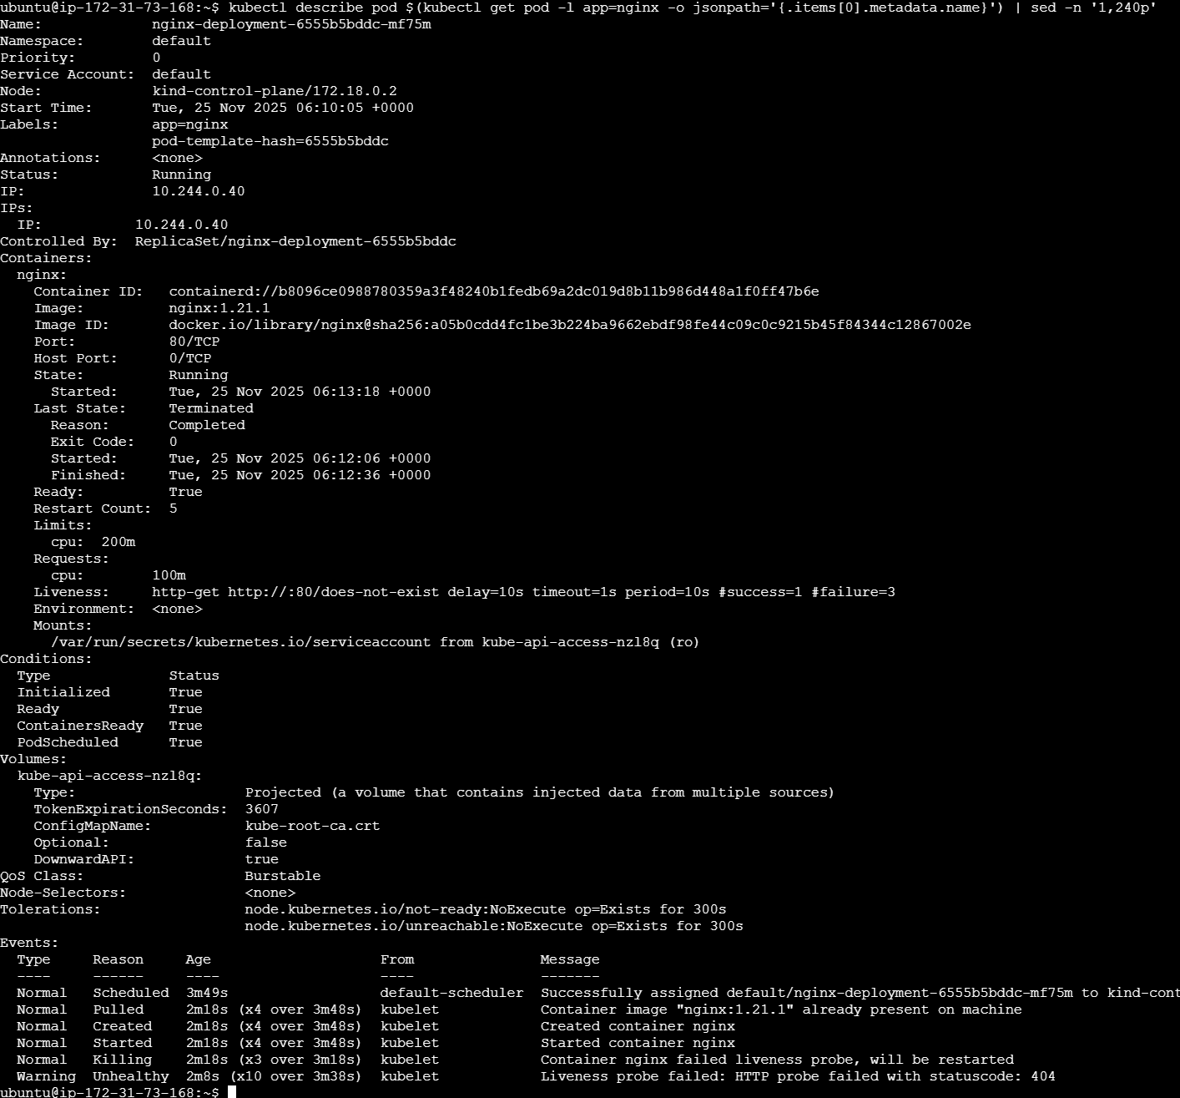
Fix the probe:
cp 01-nginx-deploy-liveness.yaml 03-nginx-liveness-fixed.yaml
kubectl apply -f 03-nginx-liveness-fixed.yaml
kubectl rollout status deployment/nginx-deployment
kubectl get pods -l app=nginx
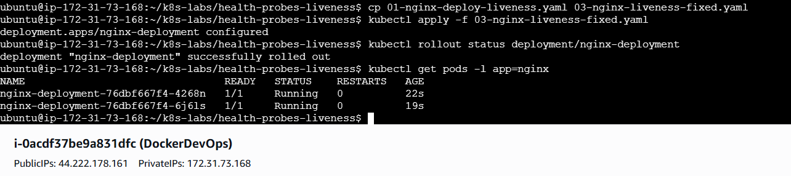
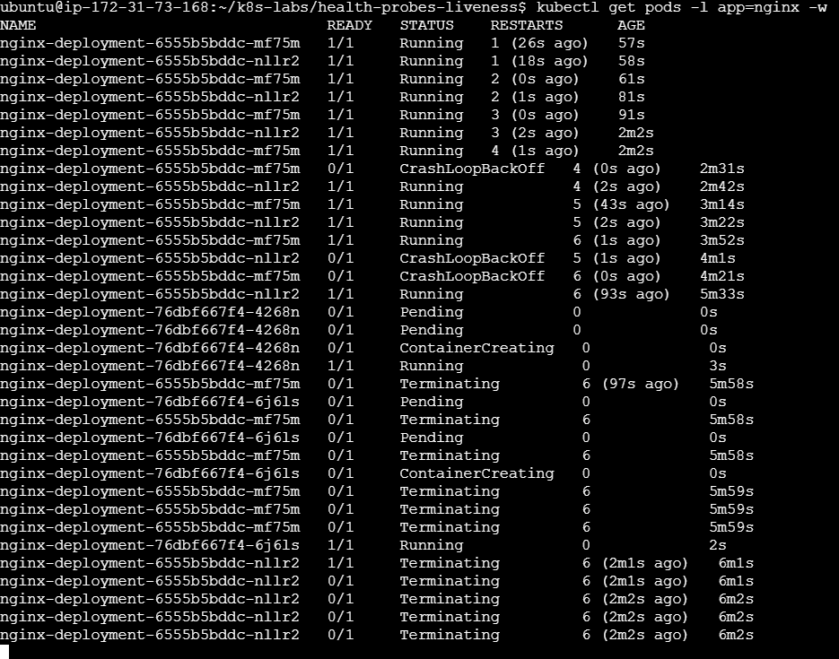
What you observed:
- The kubelet restarted the container after sustained probe failures.
- Once fixed, restarts stop climbing and the Pod returns to steady state.
Let’s recap: You created a controlled failure and watched Kubernetes self-heal by restarting the container—exactly what liveness is for.

5) Explore Real-World Impact & Safe Tuning
Liveness is powerful, but aggressive settings can cause restart loops. Use these guidelines:
- Start conservative: initialDelaySeconds: 10–15, periodSeconds: 10, timeoutSeconds: 1–2, failureThreshold: 3–5. This avoids killing containers during brief hiccups.
- Probe something cheap: Keep the liveness endpoint lightweight (no heavy DB calls). If the DB is flaky, prefer failing readiness rather than liveness. Liveness is about process health, not dependency health.
- Separate concerns:
  - Use readiness to protect users from temporary issues.
  - Use liveness to recover from deadlocks and wedged states.
- Watch RESTARTS: kubectl get pods shows the restart count. If it steadily climbs, either the app is truly broken or your liveness thresholds are too strict.
Quick drill: observe restart loops (optional)
# Keep the broken liveness file applied for 1–2 minutes and watch:
kubectl get pods -l app=nginx -w

# Then fix it again with the good file:
kubectl apply -f 03-nginx-liveness-fixed.yaml
kubectl rollout status deployment/nginx-deployment
Let’s recap: Liveness should be a last resort safety net—tuned to act on persistent unhealth, not transient slowness.

6) Troubleshooting
- No restarts happen after breaking liveness
  - Ensure you waited long enough: initialDelaySeconds + periodSeconds × failureThreshold.
  - Check events:
kubectl describe pod $(kubectl get pod -l app=nginx -o jsonpath='{.items[0].metadata.name}') | sed -n '1,240p'
  - Confirm the probe is actually failing (non-2xx/3xx or timeout).
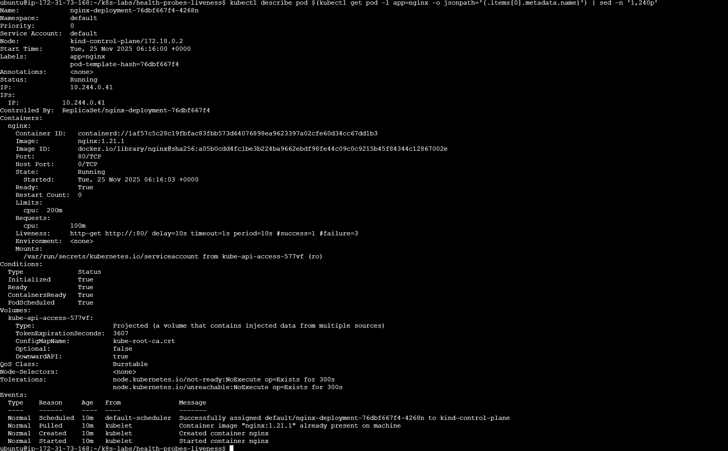
- Restarts keep climbing even after fixing the probe
  - Verify the applied YAML (kubectl get deploy nginx-deployment -o yaml | less).
  - Make sure the container actually serves on targetPort (80) and isn’t crash-looping for other reasons.
- Rollouts feel slow
  - That’s expected if Pods need time to stabilize. Consider larger initialDelaySeconds or a slightly bigger failureThreshold.

7) Clean Up (optional)
# Keep for future labs, or remove:
# kubectl delete deploy nginx-deployment

Wrap-Up — What Did You Learn?
- Liveness answers: “Should Kubernetes restart this container?”
- It’s different from readiness:
  - Readiness → traffic gating (Ready/NotReady), no restart.
  - Liveness → self-healing via restart after repeated failures.
- You:
  - Added a liveness probe.
  - Broke it intentionally (404 path) to trigger restarts.
  - Observed RESTARTS increase and events explaining why.
  - Restored a healthy probe and saw the Pod stabilize.
With readiness (availability) and liveness (survivability) mastered, your Deployments don’t just run—they tell Kubernetes how to protect users and self-heal the process.

Guided Lab 07 — Kubernetes Services (ClusterIP)
Scope: ClusterIP only. Default namespace. We’ll connect the dots between “healthy Pods” and “how anything actually reaches them,” then prove it end-to-end with hands-on drills.

1) Introduction — You’ve Built a Smart, Reliable Deployment… Now Who Finds It?
You’ve already done a lot right:
- Replicas (2): Kubernetes keeps two Pods alive.
- Resources: Requests/limits prevent CPU starvation.
- Rolling updates: No downtime during upgrades.
- Readiness: New Pods don’t receive traffic until they’re ready.
- Liveness: Wedged processes self-heal via restarts.
That’s an excellent foundation. But there’s a practical snag that appears the moment another Pod tries to talk to your app:
The Real-World Problem
- Pod IPs are ephemeral. Scale up? Roll out? Crash/restart? Pod IPs change.
- A teammate hard-codes a Pod IP to test something… ten minutes later it breaks.
- Your system works in isolation, but service-to-service communication is flaky or manual.
We need a stable way to find and reach the right Pods—only those that are Ready—no matter how often they churn.
The Concept — What a Service Is (Practically)
A Service is a stable front door for a set of Pods:
- It owns a stable virtual IP (the ClusterIP) and a stable DNS name.
- It uses a label selector (e.g., app: nginx) to decide which Pods sit behind the door.
- It load-balances across Ready endpoints, so callers don’t need to care which specific Pod serves them.
You’ll create one object—a Service—and every Pod in your namespace can reach your app at a single, unchanging name, e.g. http://nginx-svc.
How It Works (Just Enough Detail)
- You define the Service with a selector.
- Kubernetes maintains EndpointSlices (lists of Pod IP:Port) that match the selector and reflect each Pod’s Ready state.
- kube-proxy on each node programs the data path (iptables/ipvs) so traffic to the Service’s ClusterIP is distributed to the backend Pod IPs.
- CoreDNS gives your Service a DNS name: nginx-svc.default.svc.cluster.local (and the short nginx-svc from the same namespace).
Why Start with ClusterIP?
It’s the default type—internal-only. Exactly what your microservices use to talk to each other inside the cluster. We’ll prove discovery, DNS, and readiness-aware routing in a tight loop.

2) Step-by-Step Hands-On (ClusterIP)
We’ll keep files tidy but stay in the default namespace.
cd ~
mkdir -p ~/k8s-labs/services/clusterip
cd ~/k8s-labs/services/clusterip
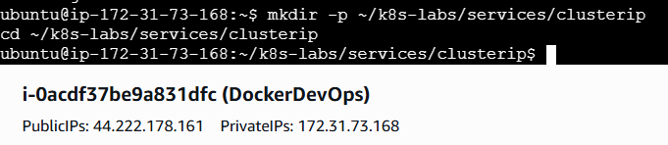
2.1 Reuse Your Deployment (probes included)
If it’s already applied from previous labs, re-applying won’t hurt—this keeps everyone aligned.
touch 00-nginx-deploy.yaml
nano 00-nginx-deploy.yaml
Paste:
apiVersion: apps/v1
kind: Deployment
metadata:
name: nginx-deployment
labels:
app: nginx
spec:
replicas: 2
selector:
matchLabels:
app: nginx
strategy:
type: RollingUpdate
rollingUpdate:
maxSurge: 1
maxUnavailable: 0
template:
metadata:
labels:
app: nginx
spec:
containers:
- name: nginx
image: nginx:1.21.1
ports:
- containerPort: 80
readinessProbe:
httpGet:
path: /
port: 80
initialDelaySeconds: 2
periodSeconds: 5
timeoutSeconds: 1
failureThreshold: 3
livenessProbe:
httpGet:
path: /
port: 80
initialDelaySeconds: 10
periodSeconds: 10
timeoutSeconds: 1
failureThreshold: 3
resources:
requests:
cpu: "100m"
limits:
cpu: "200m"
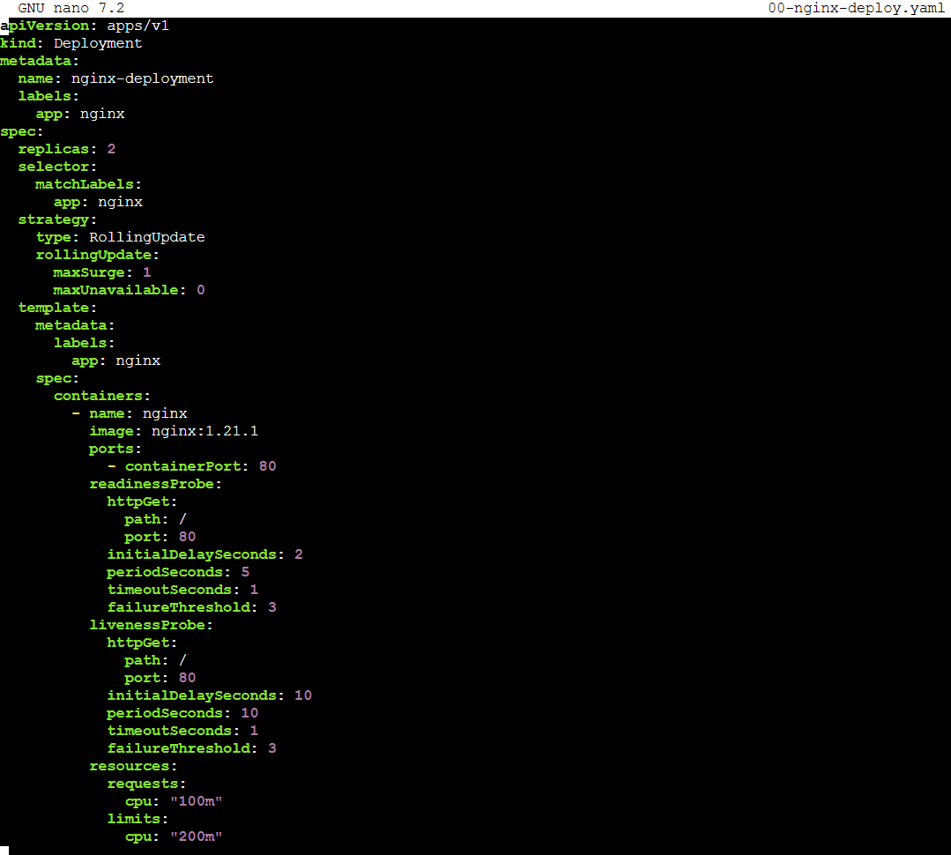
Apply and check:
kubectl apply -f 00-nginx-deploy.yaml
kubectl rollout status deploy/nginx-deployment
kubectl get pods -l app=nginx -o wide
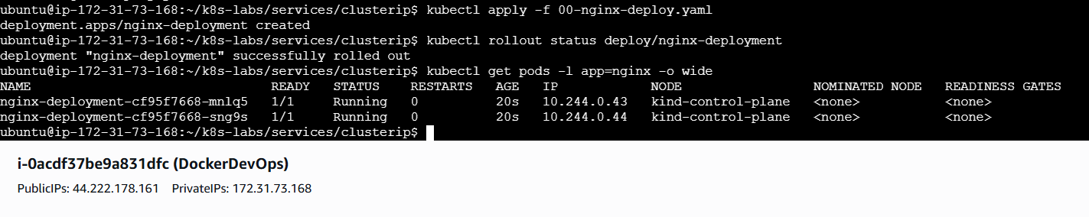
Why this matters: Labels (app: nginx) on the Pod template are the “hook” your Service will use. Readiness ensures only good Pods are considered Ready.
Let’s recap: Two healthy Pods with stable labels, listening on port 80. Perfect backends for a Service.

2.2 Create the ClusterIP Service
touch 01-nginx-svc-clusterip.yaml
nano 01-nginx-svc-clusterip.yaml
Paste:
apiVersion: v1
kind: Service
metadata:
name: nginx-svc
spec:
selector:
app: nginx
ports:
- name: http
port: 80 # Service's stable, virtual port
targetPort: 80 # Pod containerPort
type: ClusterIP # internal-only
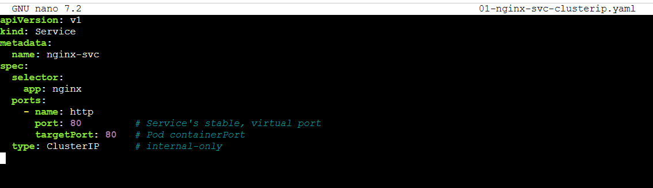
Apply and inspect:
kubectl apply -f 01-nginx-svc-clusterip.yaml
kubectl get svc nginx-svc -o wide
kubectl get endpoints nginx-svc -o wide
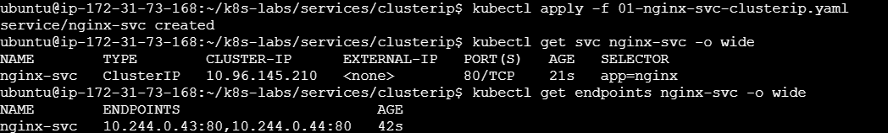
kubectl describe endpoints nginx-svc | sed -n '1,200p'
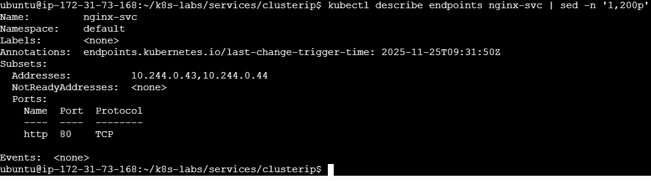
kubectl get endpointslice -l kubernetes.io/service-name=nginx-svc
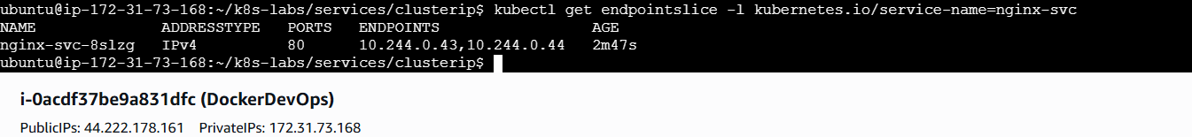
What you’re seeing:
- CLUSTER-IP — the Service’s virtual IP.
- Endpoints / EndpointSlices — the current list of matching Pod IPs and ports (and their Ready state).
Let’s recap: You now have a single front door (nginx-svc) that Kubernetes keeps pointing at the right Pods as they come and go.

2.3 Call the Service from Inside the Cluster
Spin up a tiny client Pod and make requests by name and by ClusterIP.
kubectl run tester --image=busybox:1.36 --restart=Never --command -- sh -c "sleep 3600"
kubectl get pod tester
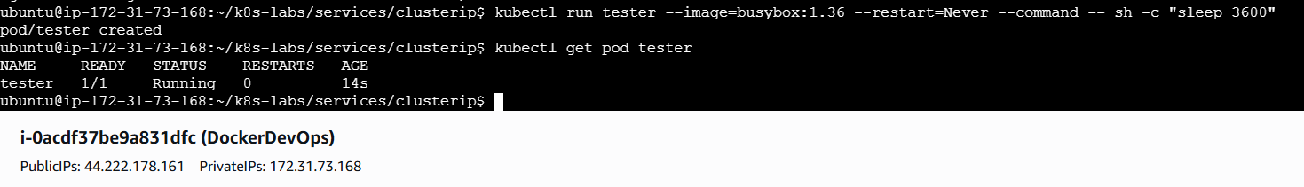
Now test:
# By DNS name (short form, same namespace)
kubectl exec -it tester -- sh -c "wget -qO- http://nginx-svc | head -n 5"
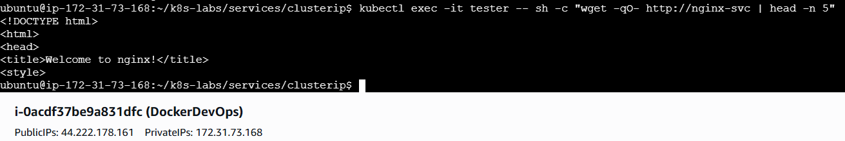
# By ClusterIP (replace with the IP shown in 'kubectl get svc')
kubectl exec -it tester -- sh -c "wget -qO- http://<CLUSTER_IP> | head -n 5"
kubectl exec -it tester -- sh -c "wget -qO- http://10.96.145.210 | head -n 5"
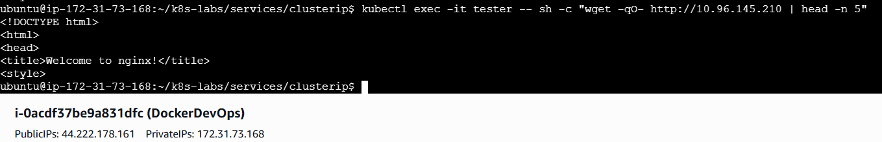
# DNS lookups via CoreDNS
kubectl exec -it tester -- nslookup nginx-svc
kubectl exec -it tester -- nslookup nginx-svc.default.svc.cluster.local
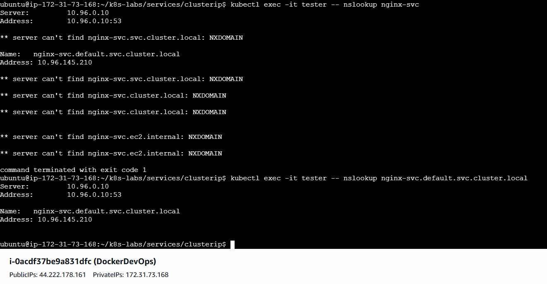
Why this proves the point: Your client doesn’t care which Pod serves the request—only that nginx-svc is stable. Kubernetes does the rest.
Let’s recap: You’ve consumed your app exactly how other services will—by name, not by Pod IP.

2.4 Show the Label/Selector Contract (Break → Observe → Fix)
If the selector doesn’t match labels, the Service has nowhere to send traffic.
cp 01-nginx-svc-clusterip.yaml 02-nginx-svc-selector-broken.yaml
nano 02-nginx-svc-selector-broken.yaml
Change:
spec:
selector:
app: does-not-match
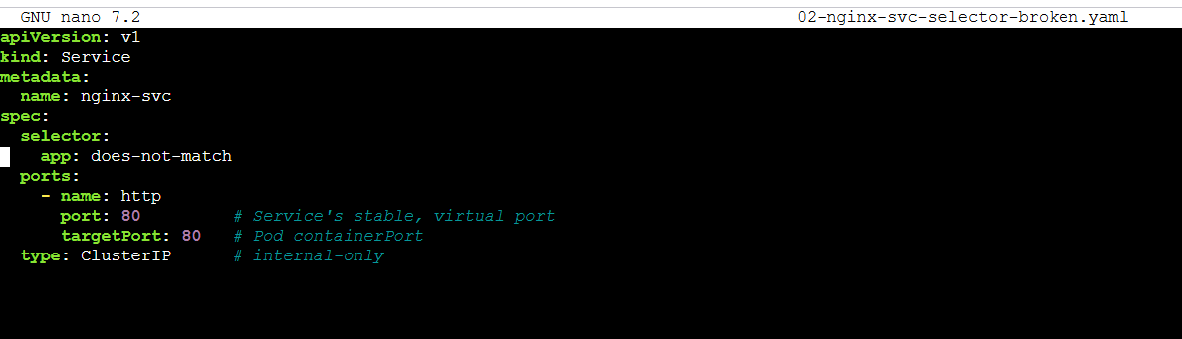
Apply and check:
kubectl apply -f 02-nginx-svc-selector-broken.yaml
kubectl get endpoints nginx-svc -o wide
kubectl describe endpoints nginx-svc | sed -n '1,200p'
Try to call it:
kubectl exec -it tester -- sh -c "wget -S -O- http://nginx-svc 2>&1 | head -n 20"
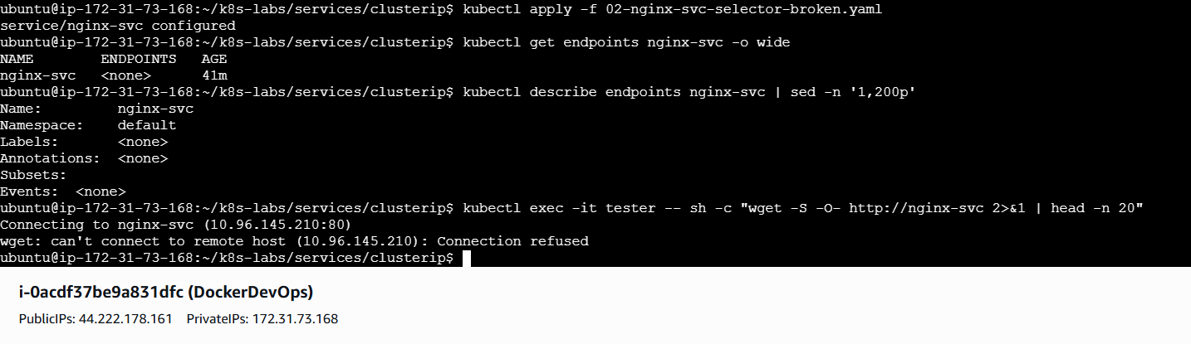
Now fix it:
kubectl apply -f 01-nginx-svc-clusterip.yaml
kubectl get endpoints nginx-svc -o wide
kubectl exec -it tester -- sh -c "wget -qO- http://nginx-svc | head -n 5"
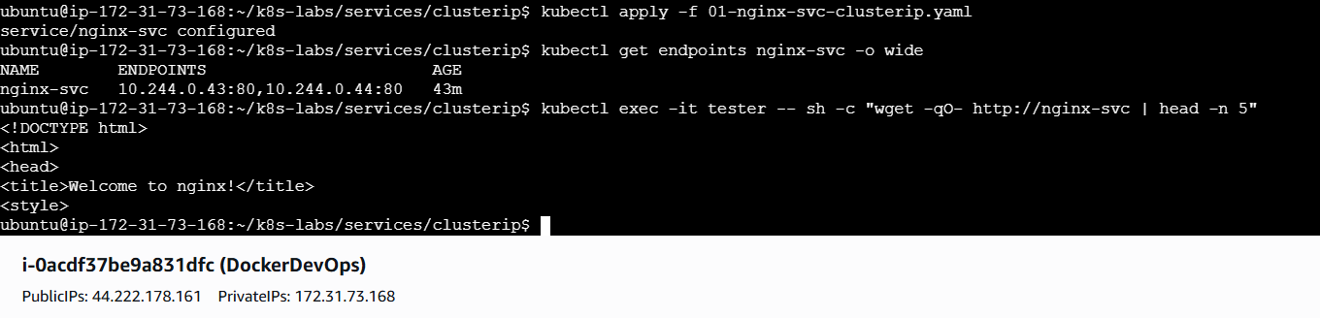
Let’s recap: Services are simple but strict—no label match, no endpoints. Your Deployment owns labels; your Service selects them.

2.5 See Readiness Influence on Routing (Quick Drill)
We’ll momentarily break readiness so a Pod is NotReady, and then observe how the Service reflects that.
- Keep things concise by scaling to one replica:
kubectl scale deploy/nginx-deployment --replicas=1
kubectl rollout status deploy/nginx-deployment
kubectl get pods -l app=nginx -o wide
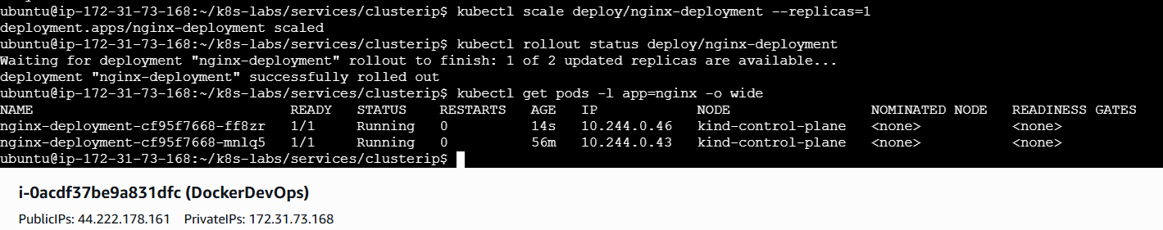
- Patch readiness to a bad path → watch it fall out of rotation:
# Save current spec (for easy restore)
kubectl get deploy nginx-deployment -o yaml > 03-deploy-backup.yaml

# Create a patch that breaks readiness
cat > 03-readiness-broken.yaml <<'EOF'
spec:
template:
spec:
containers:
- name: nginx
image: nginx:1.21.1
readinessProbe:
httpGet:
path: /does-not-exist
port: 80
initialDelaySeconds: 2
periodSeconds: 5
timeoutSeconds: 1
failureThreshold: 3
EOF
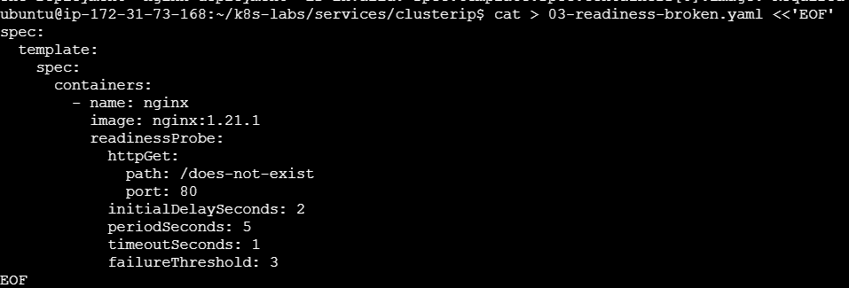
kubectl patch deploy nginx-deployment --type merge --patch-file 03-readiness-broken.yaml
kubectl rollout status deploy/nginx-deployment
kubectl get pods -l app=nginx
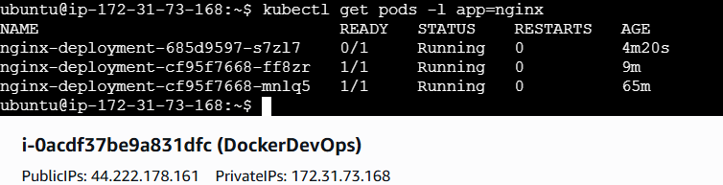
kubectl describe pod $(kubectl get pod -l app=nginx -o jsonpath='{.items[0].metadata.name}') | sed -n '1,160p'
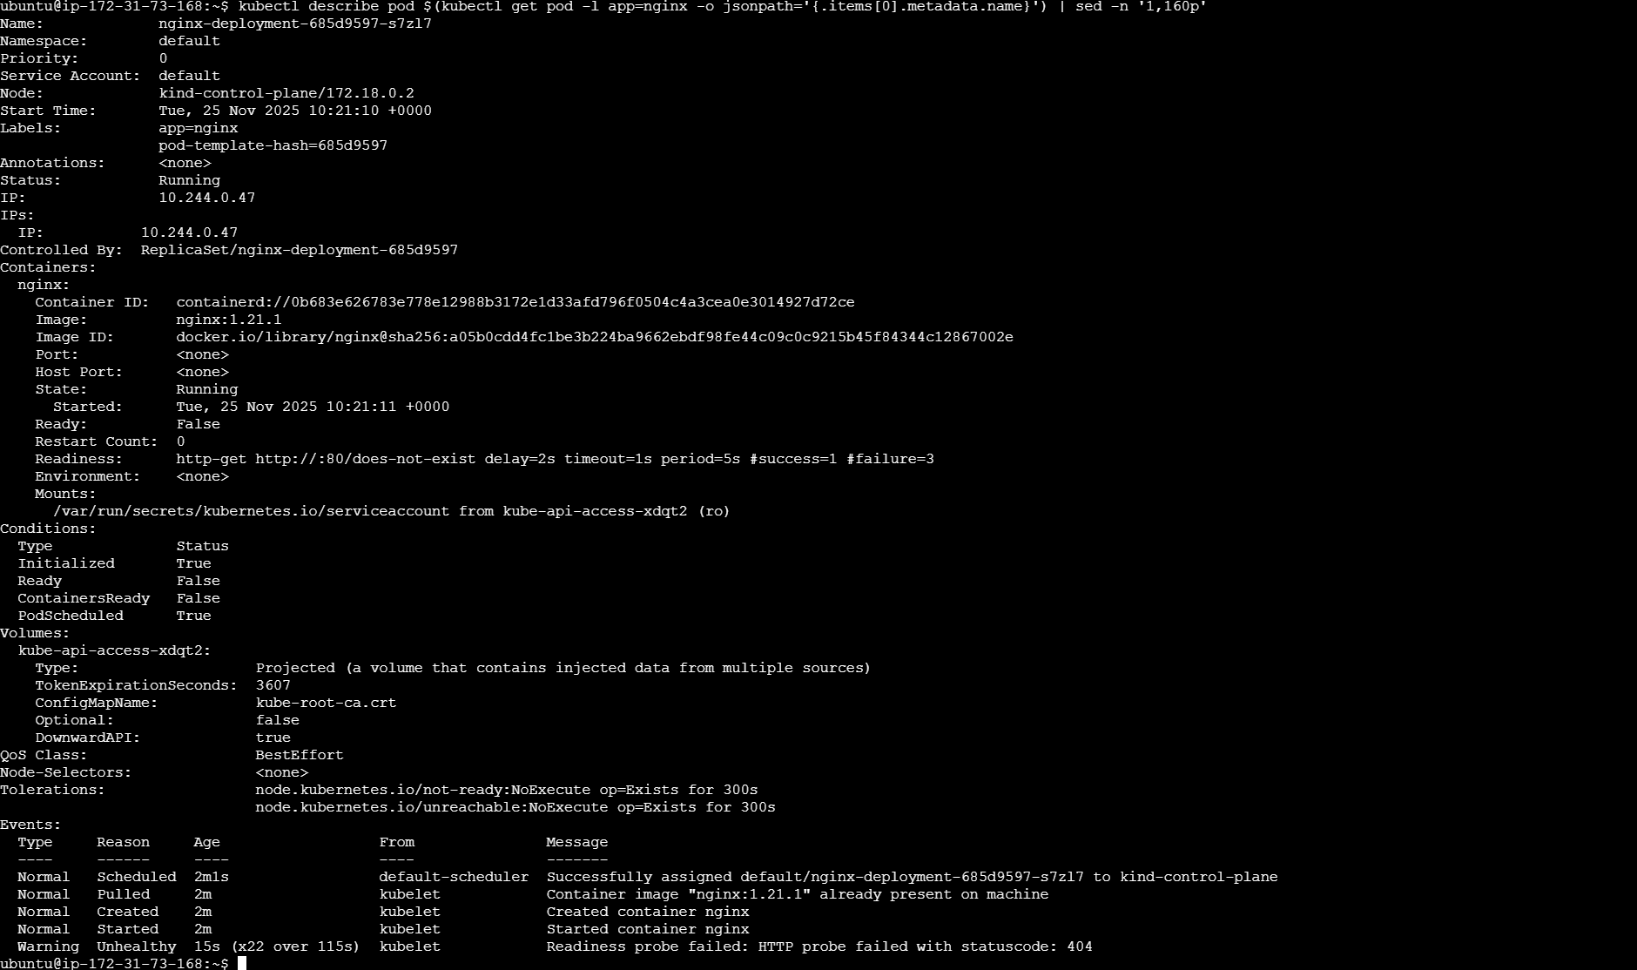
# Endpoints should now exclude this Pod (NotReady)
kubectl describe endpoints nginx-svc | sed -n '1,200p'
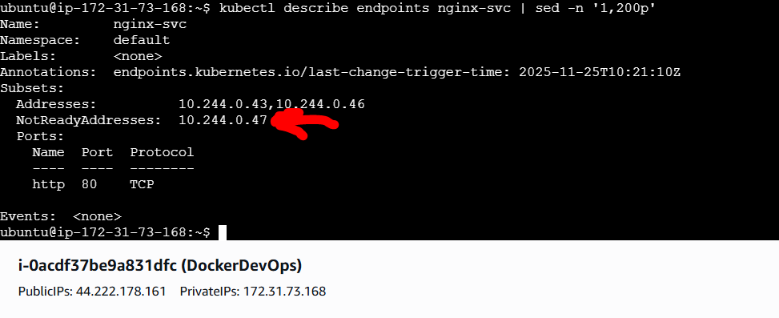
- Restore readiness:
kubectl apply -f 00-nginx-deploy.yaml
kubectl rollout status deploy/nginx-deployment
kubectl describe endpoints nginx-svc | sed -n '1,200p'
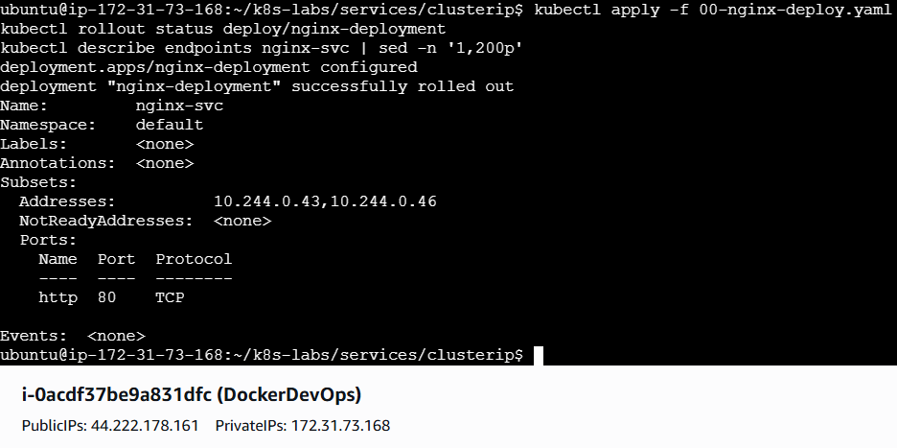
What you learned: Readiness isn’t academic—Services respect it. NotReady Pods don’t receive traffic.
Let’s recap: Readiness gates traffic; the Service’s endpoint list mirrors that truth in real time.

3) Verification & Troubleshooting
- Endpoints empty? Selector mismatch or no Ready Pods.
- kubectl get pods -l app=nginx -o wide
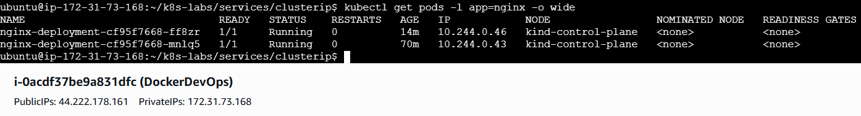
- kubectl describe svc nginx-svc | sed -n '1,160p'
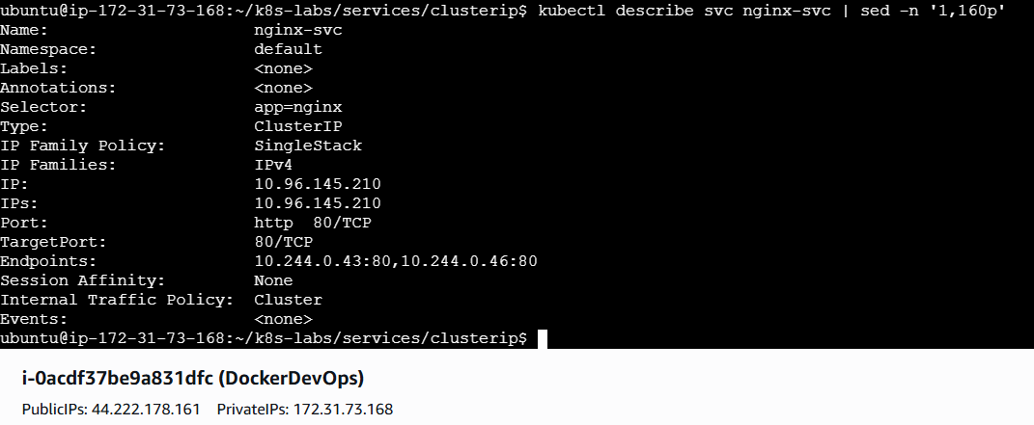
- kubectl describe endpoints nginx-svc | sed -n '1,200p'
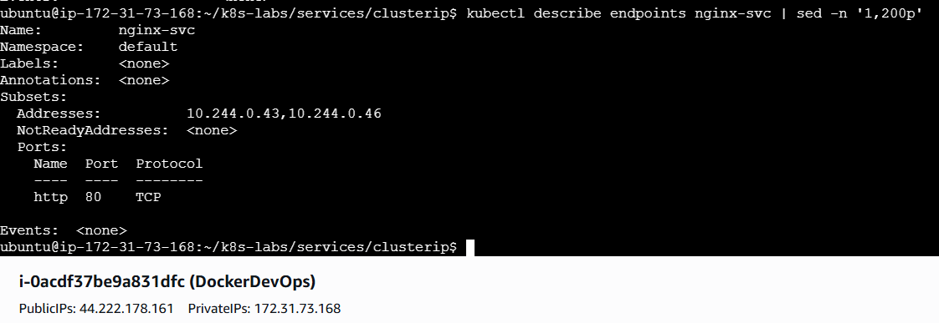
- Service exists, but requests fail intermittently
  - Pod might be flapping on readiness—check Conditions and RESTARTS:
  - kubectl describe pod $(kubectl get pod -l app=nginx -o jsonpath='{.items[0].metadata.name}') | sed -n '1,200p'
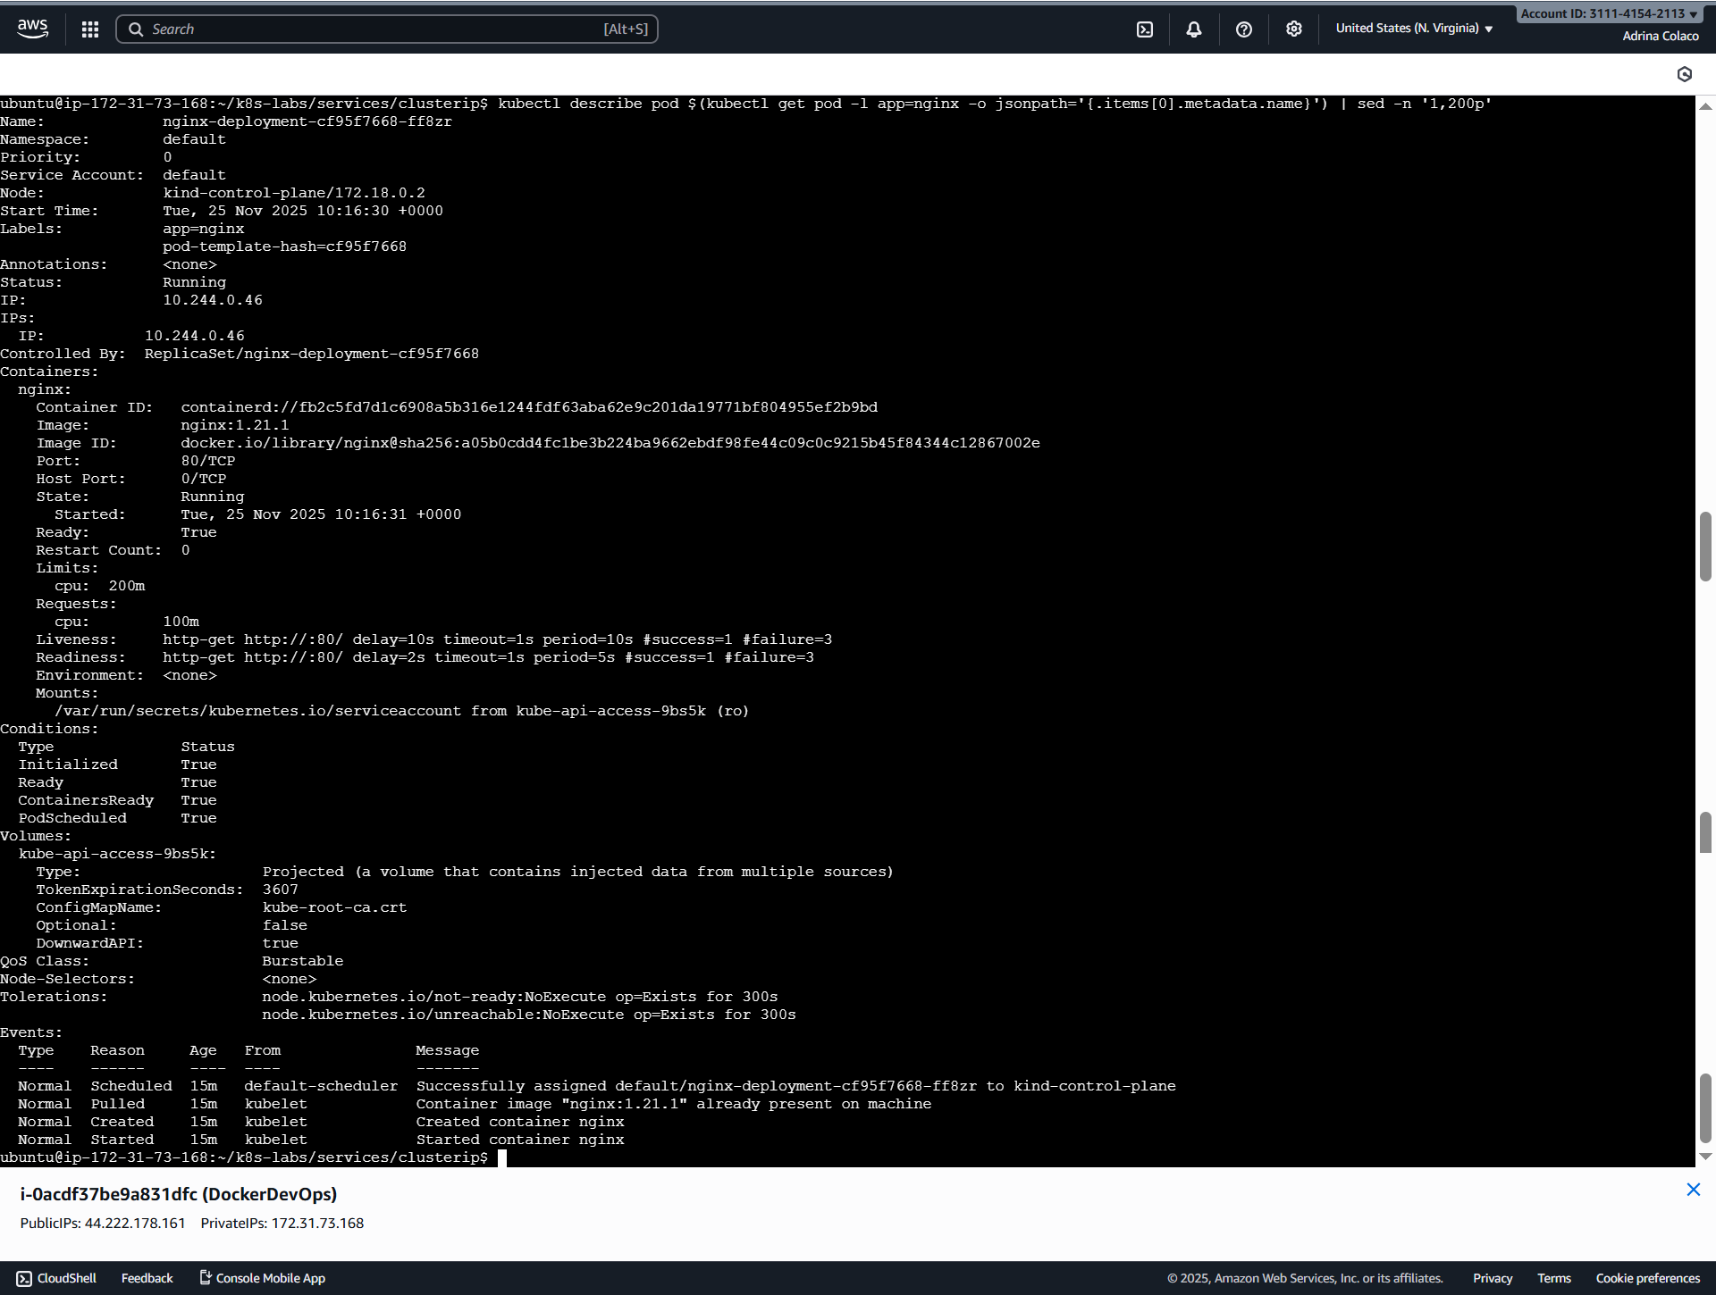
  - kubectl get pods -l app=nginx
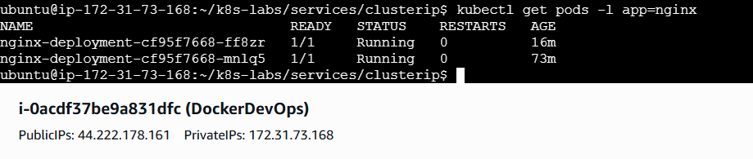
  - Ensure targetPort matches containerPort.
- DNS doesn’t resolve Verify CoreDNS:
kubectl -n kube-system get pods -l k8s-app=kube-dns
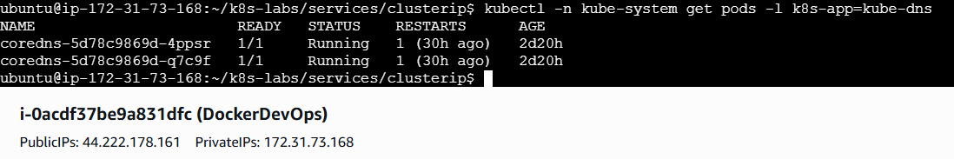
- BusyBox limitations Use wget and nslookup. If you need curl/dig, run a different toolbox image (e.g., curlimages/curl).

4) Clean Up (optional)
kubectl delete pod tester
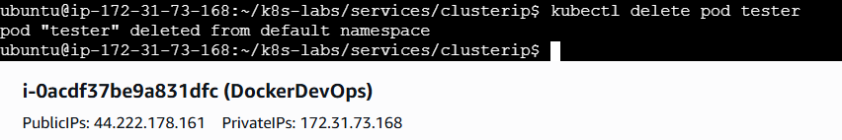
kubectl delete svc nginx-svc
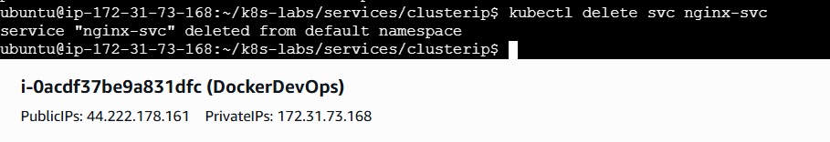
# Keep the Deployment for the next lab (NodePort), or remove it:
# kubectl delete deploy nginx-deployment

Wrap-Up — What Did You Learn?
- ClusterIP gives your app a stable, internal IP and DNS name—no more chasing Pod IPs.
- Selectors connect Services to Pods; labels make the contract explicit.
- EndpointSlices + kube-proxy steer traffic only to Ready Pods.
- You proved the full path:
  - Reused a healthy Deployment with probes
  - Created a ClusterIP Service
  - Reached it by DNS and IP from a client Pod
  - Broke and fixed the selector
  - Saw readiness immediately reflected in Service endpoints
Next up: we’ll expose the same app outside the cluster with NodePort—same labels, same Pods, just a different door.

Guided Lab 08 — Kubernetes Services (NodePort)
Scope: NodePort only. Default namespace. We’ll take the same NGINX Deployment (with readiness & liveness) and open a door to it from outside the cluster. No LoadBalancer/Ingress yet—that’s next.

1) Introduction — You Have a Stable Internal Service… But Can Users Reach It?
You’ve already solved the inside-the-cluster story:
- Replicas (2): your app survives pod churn.
- Resources: no CPU starvation.
- Rolling updates: safe upgrades.
- Readiness & Liveness: availability and self-healing.
- ClusterIP Service: stable name + internal load balancing.
But now a practical, real-world question shows up:
“I want to show this to someone outside the cluster. How do I reach it from my laptop or another network?”
You could port-forward for demos, but that’s a developer convenience, not a deployment model. You need a supported, simple way to open an external door without involving a cloud load balancer yet.
What NodePort Is (Practically)
A NodePort Service opens a high port (default range 30000–32767) on every node in your cluster. Traffic to http://<nodeIP>:<nodePort> is forwarded to your Service, which then load-balances to the matching, Ready Pods.
- It’s still a Kubernetes Service (with ClusterIP, selector, endpoints).
- NodePort adds an extra external entry point on each node.
When to Use NodePort
- Quick external access in labs or on-prem clusters without a cloud LoadBalancer.
- Simple, predictable exposure when you control the node network and firewall.
- A stepping stone before LoadBalancer (AKS/EKS/GKE) or Ingress.
We’ll create a NodePort Service, discover a node IP, and test from outside (when reachable) and from inside (always reachable).

2) Step-by-Step Hands-On (NodePort)
Keep things tidy:
cd ~
mkdir -p ~/k8s-labs/services/nodeport
cd ~/k8s-labs/services/nodeport
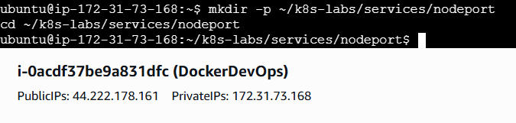
2.1 Reuse Your Deployment (probes included)
If it’s already running, re-apply anyway so everyone’s in sync.
touch 00-nginx-deploy.yaml
nano 00-nginx-deploy.yaml
Paste:
apiVersion: apps/v1
kind: Deployment
metadata:
name: nginx-deployment
labels:
app: nginx
spec:
replicas: 2
selector:
matchLabels:
app: nginx
strategy:
type: RollingUpdate
rollingUpdate:
maxSurge: 1
maxUnavailable: 0
template:
metadata:
labels:
app: nginx
spec:
containers:
- name: nginx
image: nginx:1.21.1
ports:
- containerPort: 80
readinessProbe:
httpGet:
path: /
port: 80
initialDelaySeconds: 2
periodSeconds: 5
timeoutSeconds: 1
failureThreshold: 3
livenessProbe:
httpGet:
path: /
port: 80
initialDelaySeconds: 10
periodSeconds: 10
timeoutSeconds: 1
failureThreshold: 3
resources:
requests:
cpu: "100m"
limits:
cpu: "200m"
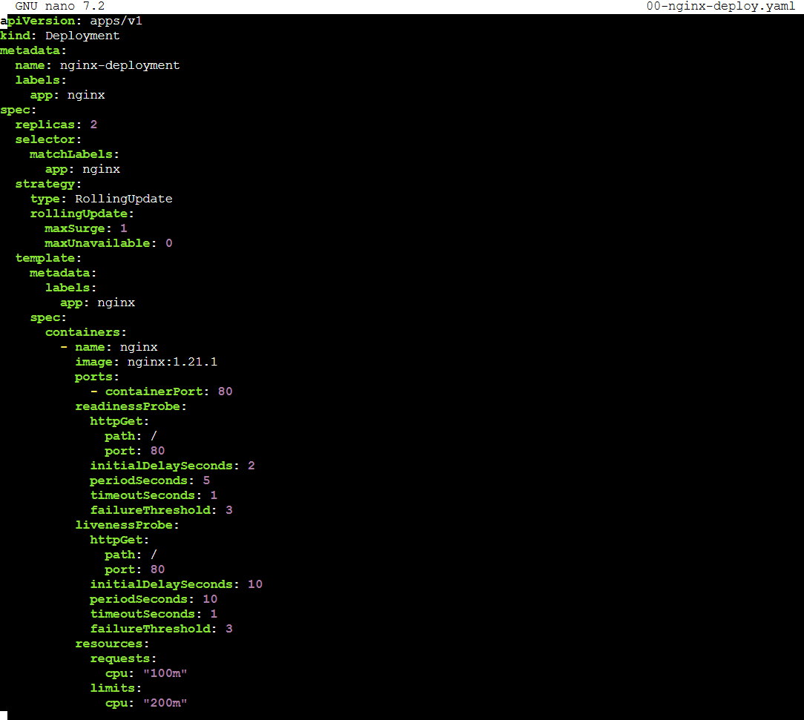
Apply and verify:
kubectl apply -f 00-nginx-deploy.yaml
kubectl rollout status deploy/nginx-deployment
kubectl get pods -l app=nginx -o wide
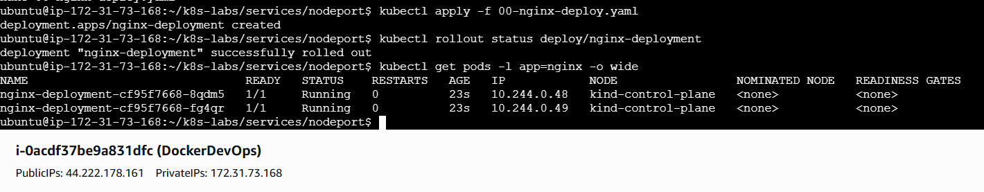
Let’s recap: Healthy Pods with stable labels (app=nginx) are ready to sit behind a NodePort door.

2.2 Create the NodePort Service
We’ll pick a fixed, easy-to-remember nodePort: 30080.
touch 01-nginx-svc-nodeport.yaml
nano 01-nginx-svc-nodeport.yaml
Paste:
apiVersion: v1
kind: Service
metadata:
name: nginx-svc-nodeport
spec:
type: NodePort
selector:
app: nginx
ports:
- name: http
port: 80 # Service's virtual port (ClusterIP)
targetPort: 80 # Pod's containerPort
nodePort: 30080 # External port open on every node (30000-32767)
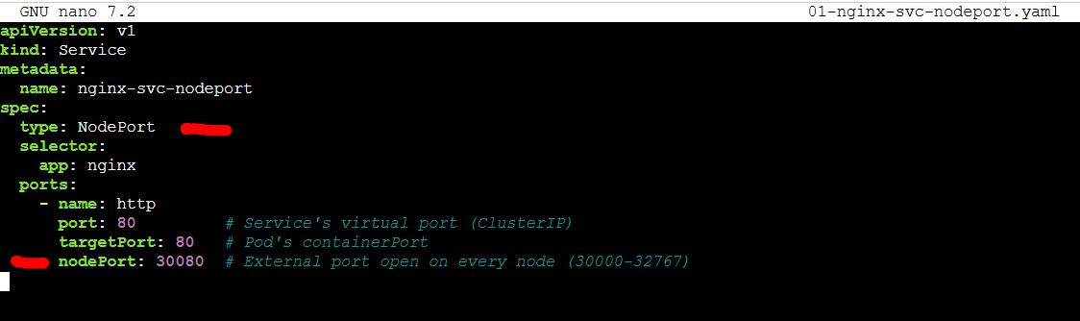
Apply and inspect:
kubectl apply -f 01-nginx-svc-nodeport.yaml
kubectl get svc nginx-svc-nodeport -o wide
kubectl get endpoints nginx-svc-nodeport -o wide
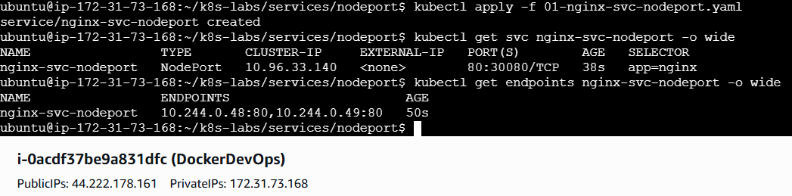
What each field does
- type: NodePort → exposes via <nodeIP>:<nodePort>.
- nodePort: 30080 → predictable external port on every node.
- port: 80 → Service’s own virtual port.
- targetPort: 80 → where the container actually listens.
Let’s recap: You’ve added an external door to the existing Service mechanics.

2.3 Find a Reachable Node IP
kubectl get nodes -o wide
- Use EXTERNAL-IP if available; otherwise INTERNAL-IP from a machine that can reach the node network.
- Minikube: prefer the helper command shown below.
- kind / Docker Desktop: node IPs may not be directly reachable from your host; see alternatives below.
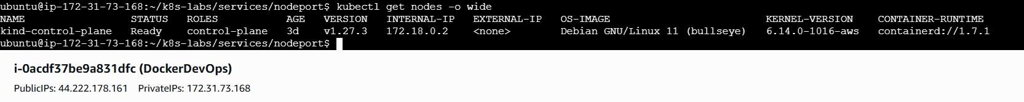

2.4 Test the NodePort
A) From your laptop (preferred if node is reachable)
# Replace <NODE_IP> with a reachable node IP
curl -I http://<NODE_IP>:30080
curl http://<NODE_IP>:30080 | head -n 10
curl -I http://172.18.0.2:30080
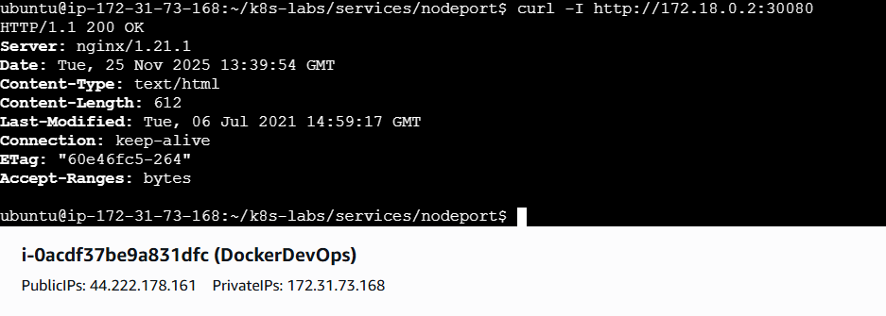
You should see NGINX headers and the default HTML body.
B) From inside the cluster (always works)
Create a tiny client pod:
kubectl run tester --image=busybox:1.36 --restart=Never --command -- sh -c "sleep 3600"
kubectl get pod tester
Call via node IP:
kubectl exec -it tester -- sh -c "wget -qO- http://<NODE_IP>:30080 | head -n 10"
kubectl exec -it tester -- sh -c "wget -qO- http://172.18.0.2:30080 | head -n 10"
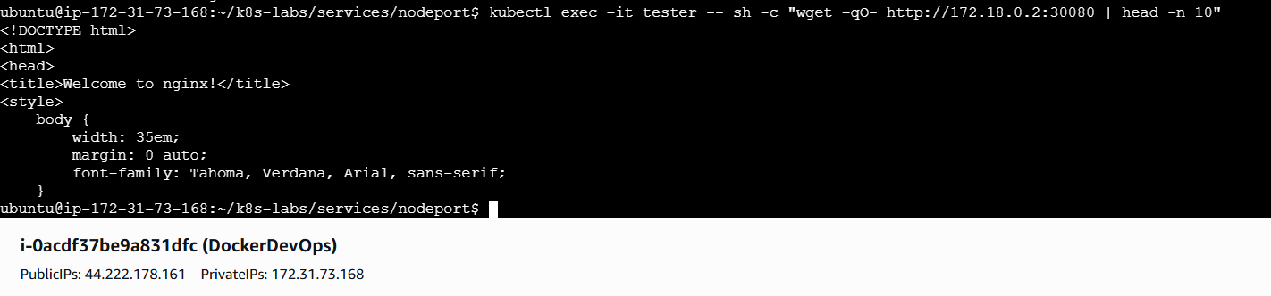
Environment notes
- Minikube:
minikube service nginx-svc-nodeport --url
This prints a usable URL that routes to the NodePort.
- kind / Docker Desktop:
  - Often can’t reach node IPs directly from the host. Use the tester pod (above), or for local demos:
  - kubectl port-forward svc/nginx-svc-nodeport 8080:80
curl http://localhost:8080
(Port-forward uses the Service but is not NodePort; helpful to validate the app.)
Let’s recap: NodePort exposes your Service externally. Whether you hit it from your laptop depends on your environment’s networking, but it always works from inside the cluster.

2.5 Prove the Selector Contract (Optional but Valuable)
Break the selector so the Service has no backends.
cp 01-nginx-svc-nodeport.yaml 02-nginx-svc-selector-broken.yaml
nano 02-nginx-svc-selector-broken.yaml
Change:
spec:
selector:
app: does-not-match
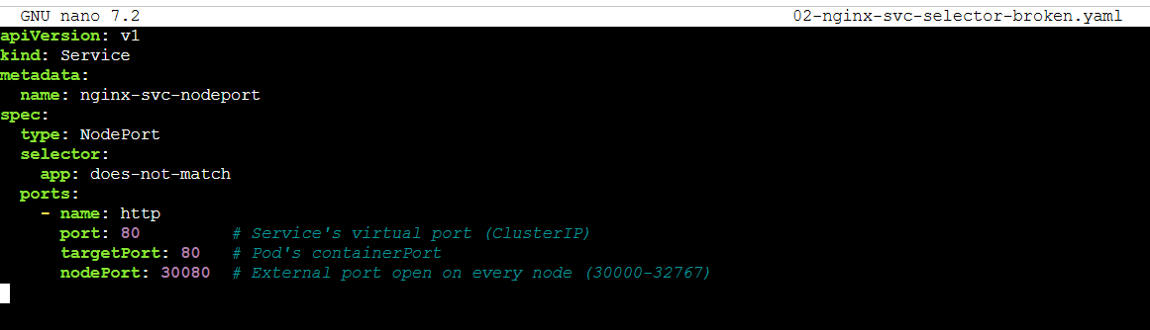
Apply and check:
kubectl apply -f 02-nginx-svc-selector-broken.yaml
kubectl get endpoints nginx-svc-nodeport -o wide
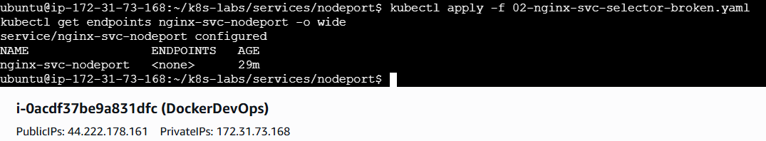
Try to call again:
curl -I http://<NODE_IP>:30080 || true
Fix it:
kubectl apply -f 01-nginx-svc-nodeport.yaml
kubectl get endpoints nginx-svc-nodeport -o wide
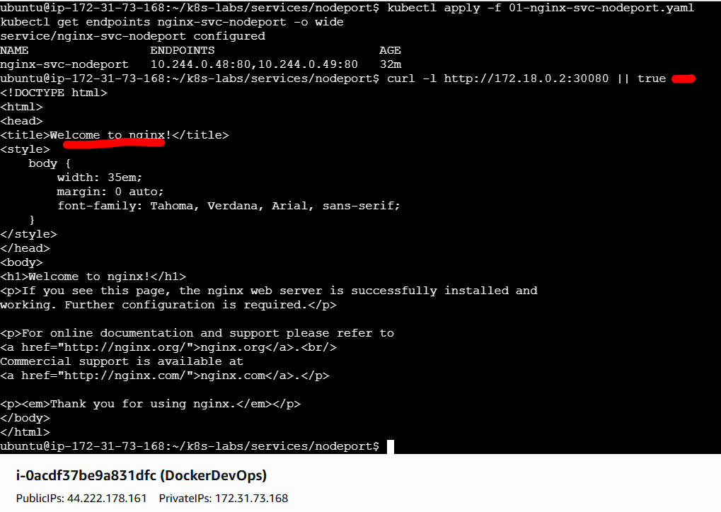
Let’s recap: NodePort is just a door. Without matching, Ready Pods, there’s nowhere to send traffic.

2.6 See Resilience During Pod Churn (Quick Drill)
Delete a Pod and keep calling the NodePort:
POD=$(kubectl get pod -l app=nginx -o jsonpath='{.items[0].metadata.name}')
kubectl delete pod "$POD"
kubectl get pods -l app=nginx -w
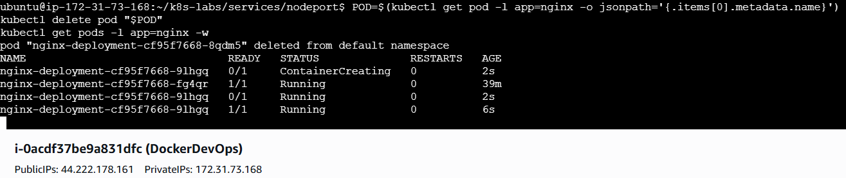
# In another terminal:
curl -I http://<NODE_IP>:30080
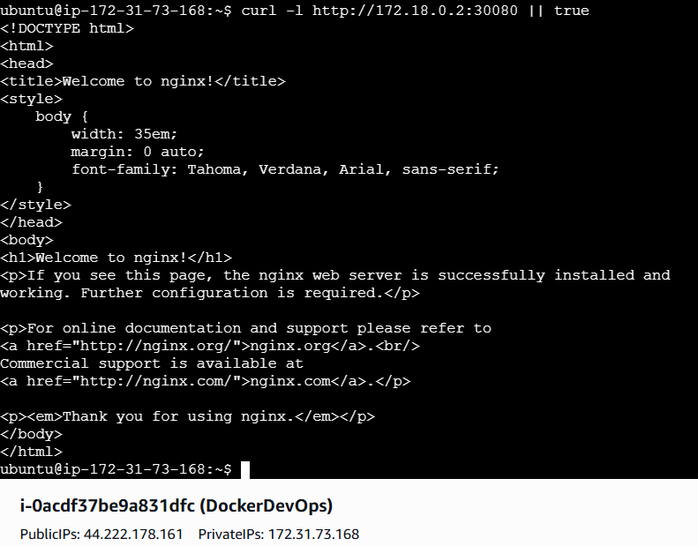
What you’ll notice: One Pod terminates, the Deployment recreates it, and the Service keeps serving as long as at least one Pod is Ready.
Let’s recap: Services abstract churn. NodePort doesn’t change that—it simply gives you an external entry point.

3) Verification & Troubleshooting
- curl <NODE_IP>:30080 times out from your laptop
  - Firewall/NAT may block node access. Try from inside the cluster (tester pod).
  - On Minikube, use minikube service … --url.
  - Confirm Service and endpoints:
  - kubectl get svc nginx-svc-nodeport -o wide
kubectl get endpoints nginx-svc-nodeport -o wide
- Endpoints are empty
  - Label mismatch or Pods not Ready:
  - kubectl get pods -l app=nginx -o wide
  - kubectl describe svc nginx-svc-nodeport | sed -n '1,160p'
kubectl describe endpoints nginx-svc-nodeport | sed -n '1,200p'
- Intermittent failures
  - One Pod may be NotReady or crash-looping. Check conditions and restarts:
  - kubectl get pods -l app=nginx
kubectl describe pod $(kubectl get pod -l app=nginx -o jsonpath='{.items[0].metadata.name}') | sed -n '1,200p'
- Wrong ports
  - Ensure targetPort matches containerPort: 80, and that your app listens on 80.

4) Clean Up (optional)
kubectl delete pod tester
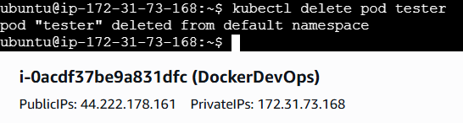
kubectl delete svc nginx-svc-nodeport
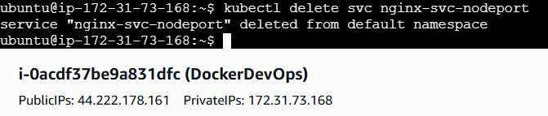
# Keep the Deployment for future labs (LoadBalancer/Ingress), or remove it:
# kubectl delete deploy nginx-deployment
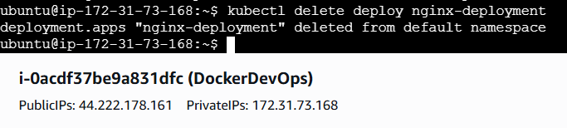

Wrap-Up — What Did You Learn?
- NodePort adds an external entry point: <nodeIP>:<nodePort> on every node.
- It builds on the same fundamentals: labels → selector → endpoints → Ready Pods.
- You verified reachability from both outside (when networking allows) and inside the cluster.
- You saw that NodePort is just a door—it’s only useful if it leads to healthy, matching backends.
Next step: Move to cloud exposure with type: LoadBalancer (e.g., AKS). Same Deployment and labels, but Kubernetes will provision a cloud load balancer and public IP for true internet-facing access.

Guided Lab 09 — Kubernetes Services (LoadBalancer)
Scope: type: LoadBalancer on a real cloud cluster (AKS). Default namespace. We’ll provision a small AKS cluster, deploy the same NGINX app (with readiness & liveness), expose it with a public IP, and verify end-to-end from the internet. No Ingress yet—that comes later.

1) Introduction — You Have Internal & Node-Level Access… But What About the Internet?
You’ve already covered:
- ClusterIP — stable, in-cluster communication by name.
- NodePort — quick external door via <nodeIP>:<nodePort> on every node.
Those are great—but product teams usually ask a different question:
“Can our users on the public internet reach this service at a stable IP/DNS without knowing node IPs or odd ports?”
That’s where a LoadBalancer Service shines.
What a LoadBalancer Service Is (Practically)
- You declare type: LoadBalancer on your Service.
- Kubernetes talks to the cloud provider (here: Azure) to provision a cloud load balancer + public IP.
- Traffic to that public IP is sent to your cluster and load-balanced across Ready Pods (through NodePorts/ClusterIP behind the scenes).
Why It Matters
- Stable, internet-facing endpoint without managing external LBs yourself.
- First production-like exposure: real public IP, real cloud primitives.
- Same Deployment and labels. Only the Service type changes.
We’ll stand up AKS, deploy the app, create a LoadBalancer Service, wait for an EXTERNAL-IP, and curl it from your machine.

2) Prepare a Small AKS Cluster (One-Time for this Lab)
Requires Azure CLI logged into an Azure subscription with permissions to create resources.
# 2.1 Create a resource group
az group create -n rg-aks-lb-lab -l westeurope
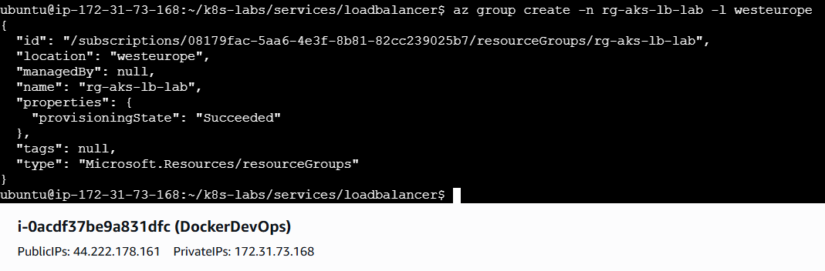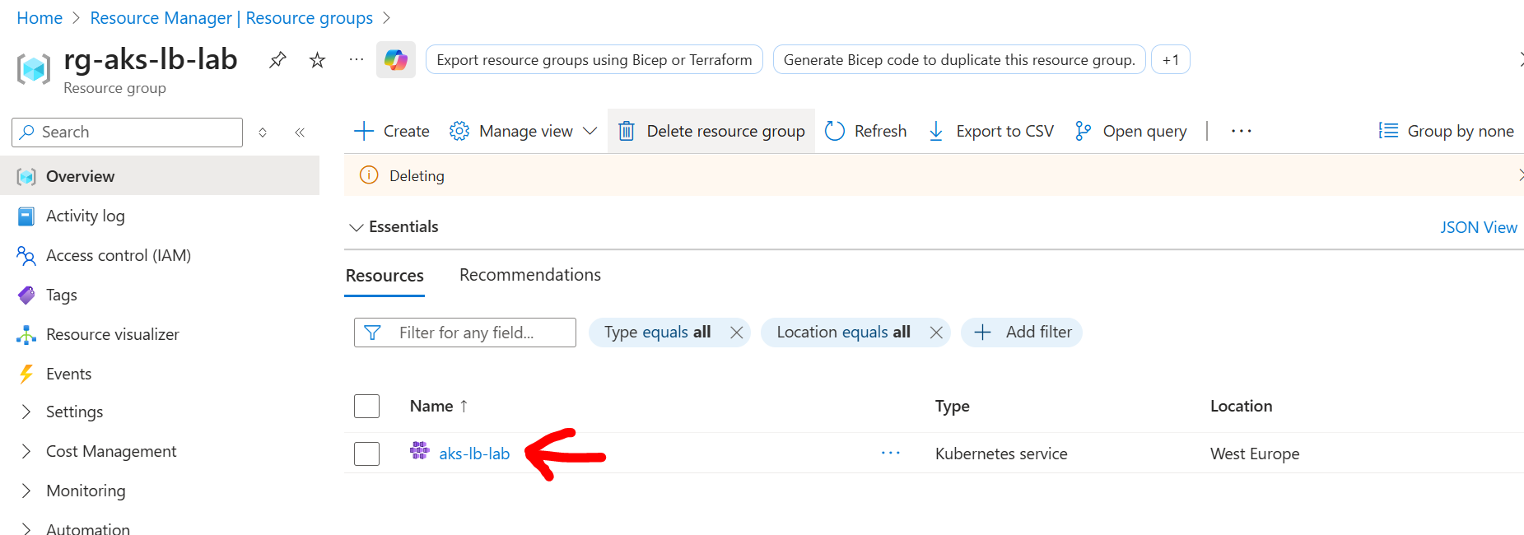

# 2.2 Create a minimal AKS cluster (1 node is fine for the lab)
az aks create -g rg-aks-lb-lab -n aks-lb-lab --node-count 1 --generate-ssh-keys --node-vm-size Standard_B2s
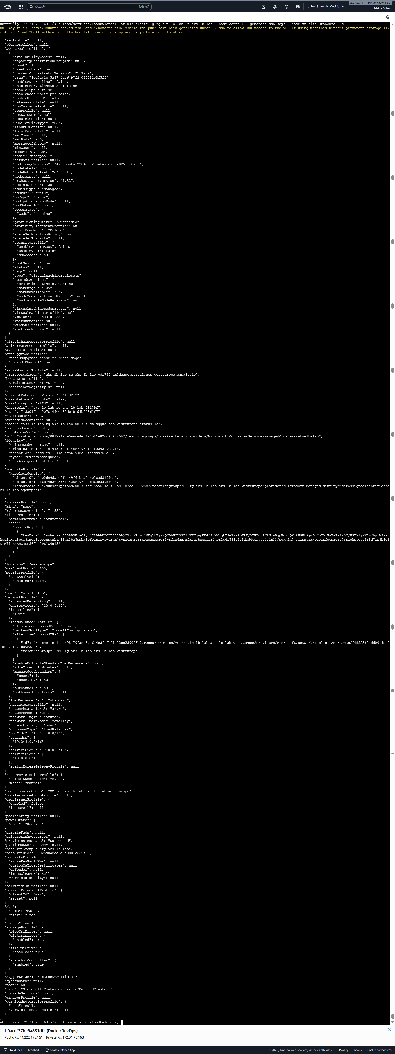
# 2.3 Fetch kubeconfig
az aks get-credentials -g rg-aks-lb-lab -n aks-lb-lab
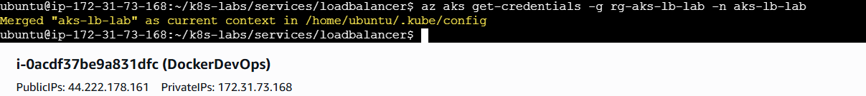
# 2.4 Verify connectivity
kubectl get nodes
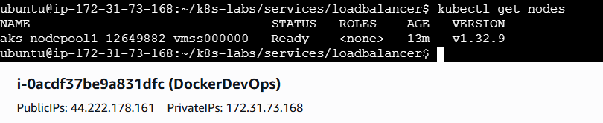
What this does (at a glance):
- Creates a managed Kubernetes control plane and a node pool.
- Configures your kubectl to talk to AKS.
Let’s recap: You now have a real cloud cluster where type: LoadBalancer can provision an Azure public IP automatically.

3) Reuse Your Deployment (Probes Included)
Keep files tidy:
cd ~
mkdir -p ~/k8s-labs/services/loadbalancer
cd ~/k8s-labs/services/loadbalancer
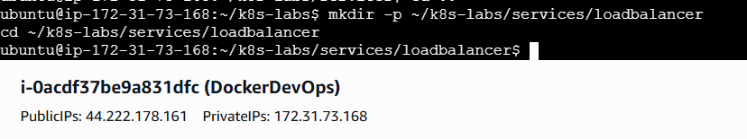
Create the Deployment:
touch 00-nginx-deploy.yaml
nano 00-nginx-deploy.yaml
Paste:
apiVersion: apps/v1
kind: Deployment
metadata:
name: nginx-deployment
labels:
app: nginx
spec:
replicas: 2
selector:
matchLabels:
app: nginx
strategy:
type: RollingUpdate
rollingUpdate:
maxSurge: 1
maxUnavailable: 0
template:
metadata:
labels:
app: nginx
spec:
containers:
- name: nginx
image: nginx:1.21.1
ports:
- containerPort: 80
readinessProbe:
httpGet:
path: /
port: 80
initialDelaySeconds: 2
periodSeconds: 5
timeoutSeconds: 1
failureThreshold: 3
livenessProbe:
httpGet:
path: /
port: 80
initialDelaySeconds: 10
periodSeconds: 10
timeoutSeconds: 1
failureThreshold: 3
resources:
requests:
cpu: "100m"
limits:
cpu: "200m"
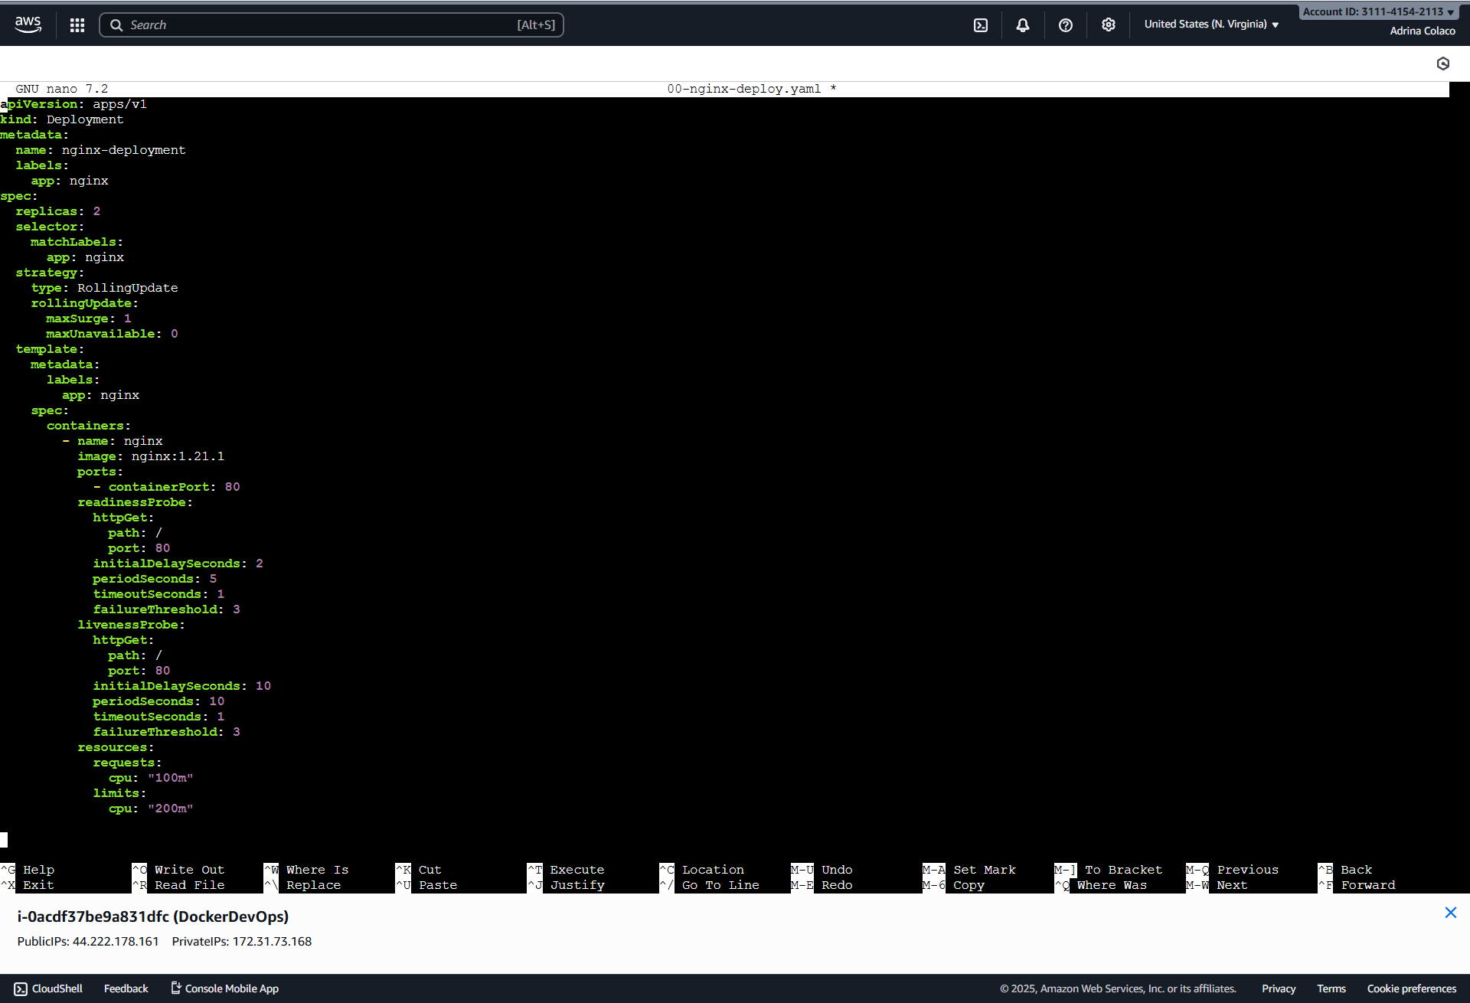
Apply and confirm:
kubectl apply -f 00-nginx-deploy.yaml
kubectl rollout status deploy/nginx-deployment
kubectl get pods -l app=nginx -o wide
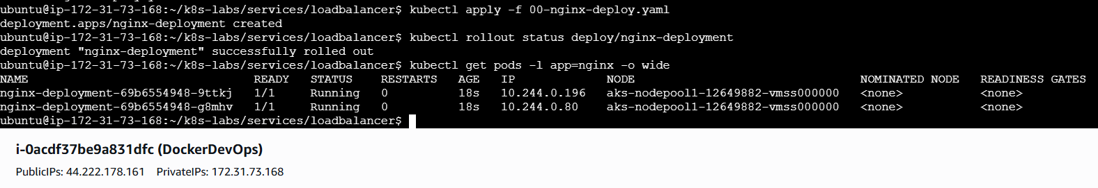
Why this matters: The Deployment sets labels (app: nginx) and exposes container port: 80. Readiness will control which Pods are eligible for traffic.
Recap: Two healthy Pods, ready to sit behind a cloud load balancer.

4) Create a LoadBalancer Service
touch 01-nginx-svc-loadbalancer.yaml
nano 01-nginx-svc-loadbalancer.yaml
Paste:
apiVersion: v1
kind: Service
metadata:
name: nginx-svc-lb
spec:
type: LoadBalancer
selector:
app: nginx
ports:
- name: http
port: 80 # Service port (public-facing)
targetPort: 80 # Pod's containerPort
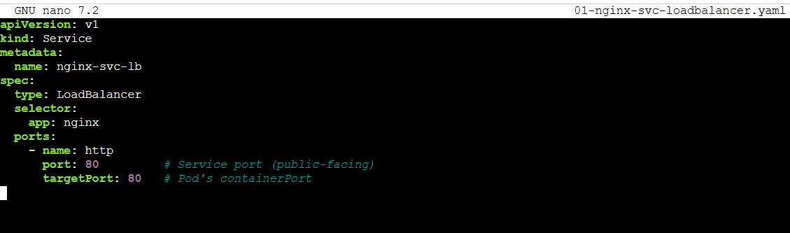
Apply and watch for a public IP:
kubectl apply -f 01-nginx-svc-loadbalancer.yaml

# Watch until EXTERNAL-IP is allocated (may take 30-120s)
kubectl get svc nginx-svc-lb -w
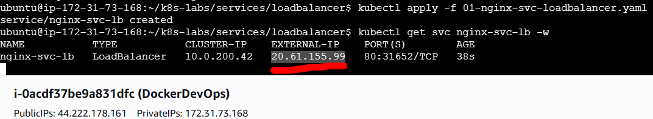
When EXTERNAL-IP shows a value (e.g., 20.101.x.y), open a new terminal and test:
EXTERNAL_IP=$(kubectl get svc nginx-svc-lb -o jsonpath='{.status.loadBalancer.ingress[0].ip}')
curl -I http://$EXTERNAL_IP
curl http://$EXTERNAL_IP | head -n 10
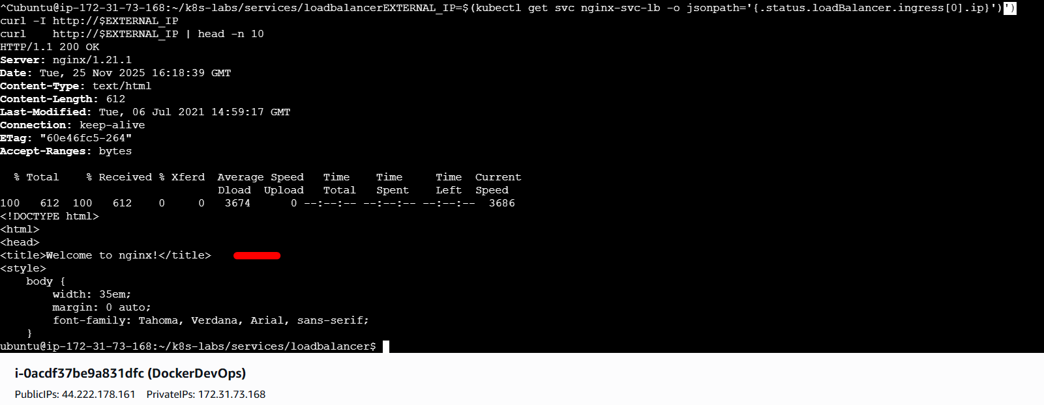
What just happened behind the scenes:
- AKS created an Azure Public IP and an Azure Load Balancer.
- The LB forwards to NodePorts in your cluster (wired by Kubernetes), then to Ready endpoints selected by your Service’s labels.
Let’s recap: With one YAML change (type: LoadBalancer), you exposed the app to the internet—no custom infra work.

5) Quick Drills to Build Intuition
5.1 Readiness affects real users
Break readiness briefly and observe accessibility.
# Create a patch that makes readiness fail
cat > 02-readiness-broken.yaml <<'EOF'
spec:
template:
spec:
containers:
- name: nginx
image: nginx:1.21.1
readinessProbe:
httpGet:
path: /does-not-exist
port: 80
initialDelaySeconds: 2
periodSeconds: 5
timeoutSeconds: 1
failureThreshold: 3
EOF
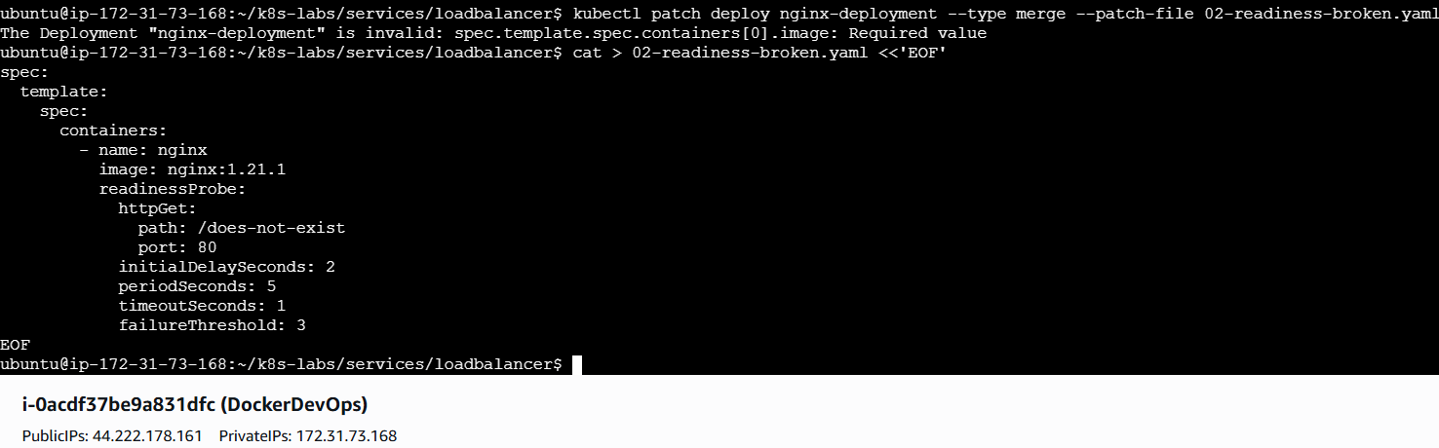
kubectl patch deploy nginx-deployment --type merge --patch-file 02-readiness-broken.yaml
kubectl rollout status deploy/nginx-deployment

# Endpoints should shrink / exclude NotReady Pods
kubectl describe endpoints nginx-svc-lb | sed -n '1,200p'
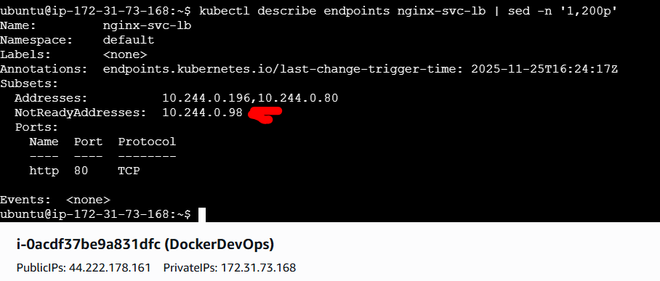
# From your machine — retry a few times
curl -I http://$EXTERNAL_IP
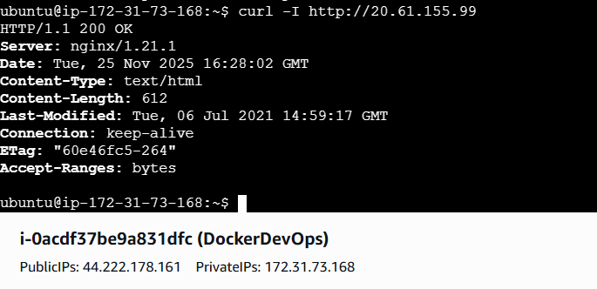
Now fix it:
kubectl apply -f 00-nginx-deploy.yaml
kubectl rollout status deploy/nginx-deployment
kubectl describe endpoints nginx-svc-lb | sed -n '1,200p'
curl -I http://$EXTERNAL_IP
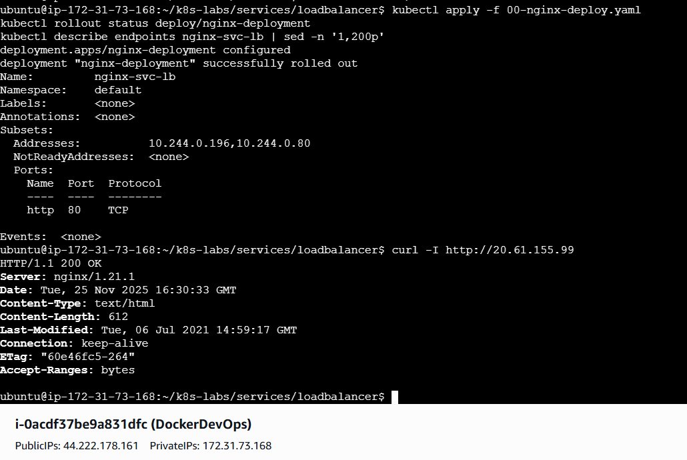
What you learned: The public LoadBalancer respects readiness all the way down; NotReady Pods drop out of rotation.

5.2 Scale and observe load balancing
Scale up and watch endpoints grow:
kubectl scale deploy/nginx-deployment --replicas=4
kubectl rollout status deploy/nginx-deployment
kubectl get endpoints nginx-svc-lb -o wide
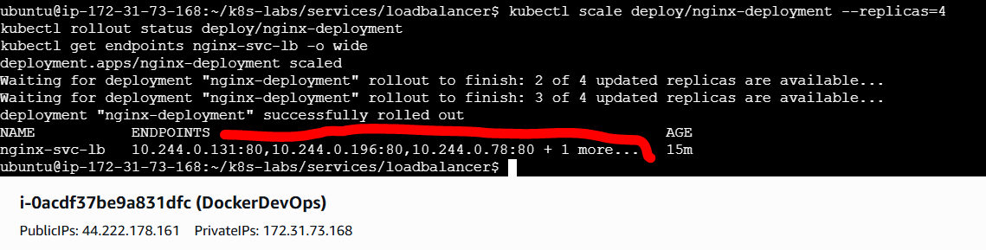
Call the external IP multiple times (you may see different Server headers/connection details across requests depending on client behavior and LB config, but the key is more endpoints are eligible).
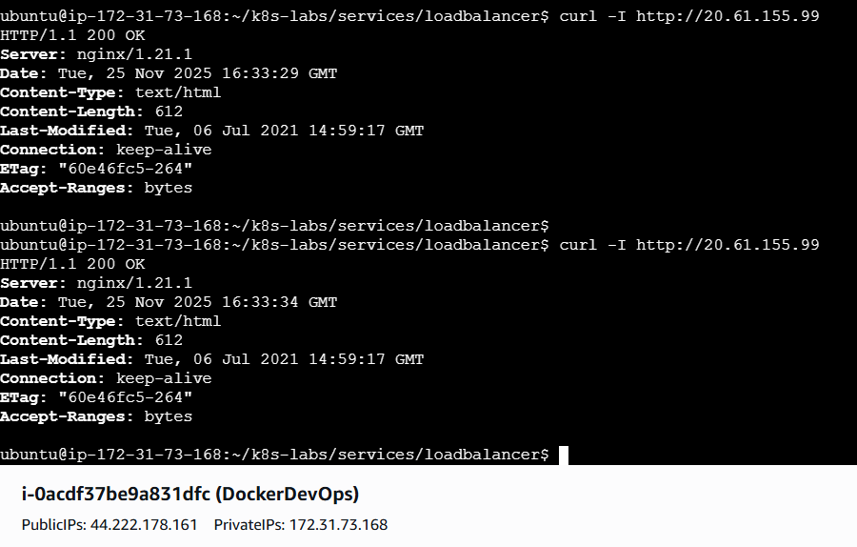
Recap: The cloud LB fronts your Service, which fronts multiple Ready Pods—scaling feels natural to the caller.

6) Troubleshooting
- EXTERNAL-IP stays <pending>
  - Ensure you’re on a cloud cluster (AKS) with the Azure cloud provider enabled (the default for AKS).
  - Check Service events:
kubectl describe svc nginx-svc-lb | sed -n '1,200p'
  - Verify the AKS cluster is in a ready state:
az aks show -g rg-aks-lb-lab -n aks-lb-lab --query "provisioningState"
- Public IP works intermittently
  - Check Pod readiness and restarts:
  - kubectl get pods -l app=nginx
kubectl describe pod $(kubectl get pod -l app=nginx -o jsonpath='{.items[0].metadata.name}') | sed -n '1,240p'
  - Ensure targetPort matches the containerPort (80).
- Need HTTPS / custom ports
  - For this lab, we stick to port 80. TLS/host routing belongs to Ingress (up next).
- You’re not using AKS
  - On minikube, you can simulate with:
  - # Start a tunnel to allocate an external IP locally
  - minikube tunnel
  - kubectl apply -f 01-nginx-svc-loadbalancer.yaml
kubectl get svc nginx-svc-lb -w
  - On bare metal, consider MetalLB (out of scope for this lab).

7) Clean Up (optional)
# Kubernetes objects
kubectl delete svc nginx-svc-lb
kubectl delete deploy nginx-deployment

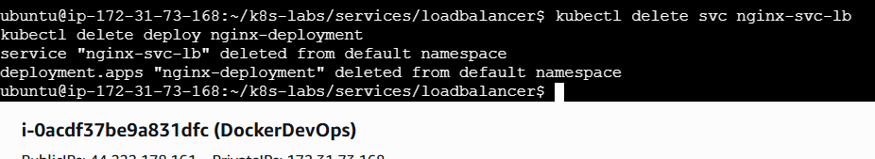
# Azure resources
az group delete -n rg-aks-lb-lab --yes --no-wait
(If you plan to do the Ingress lab next on the same cluster, keep the AKS resources and only delete the Service/Deployment.)

Wrap-Up — What Did You Learn?
- type: LoadBalancer gives you a public IP fronting your Service—no manual LB setup.
- Azure (AKS) automatically provisions the cloud load balancer and wires it to your cluster.
- The whole path remains label/selector → EndpointSlices (Ready only) → kube-proxy → NodePorts → Pods.
- You verified end-to-end from the public internet, saw readiness affect traffic, and experienced scaling behind a stable public endpoint.

LinkedIn Post1:
https://www.linkedin.com/posts/adrina-colaco_creating-my-first-kubernetes-pod-imperative-activity-7398742679703965697-NPYP?utm_source=share&utm_medium=member_desktop&rcm=ACoAAAPhxLwBOfaV_xhbVwfcuz8dVOvN7T9q0RM
LinkedIn post2:
https://www.linkedin.com/posts/adrina-colaco_replicasets-auto-healing-in-kubernetes-activity-7398744710707732481-jKB8?utm_source=share&utm_medium=member_desktop&rcm=ACoAAAPhxLwBOfaV_xhbVwfcuz8dVOvN7T9q0RM
LinkedIn post3:
https://www.linkedin.com/posts/adrina-colaco_deployments-rolling-updates-rollbacks-activity-7398972561805643776-w_Co?utm_source=share&utm_medium=member_desktop&rcm=ACoAAAPhxLwBOfaV_xhbVwfcuz8dVOvN7T9q0RM
LinkedIn post4:
https://www.linkedin.com/posts/adrina-colaco_auto-healing-horizontal-pod-autoscaling-activity-7398974360247652352-LRCP?utm_source=share&utm_medium=member_desktop&rcm=ACoAAAPhxLwBOfaV_xhbVwfcuz8dVOvN7T9q0RM
LinkedIn post5:
https://www.linkedin.com/posts/adrina-colaco_kubernetes-readiness-probes-zero-downtime-activity-7399108950828400640-FFNB?utm_source=share&utm_medium=member_desktop&rcm=ACoAAAPhxLwBOfaV_xhbVwfcuz8dVOvN7T9q0RM
LinkedIn post6:
https://www.linkedin.com/posts/adrina-colaco_liveness-probes-self-healing-containers-activity-7399129505723764736-SeNh?utm_source=share&utm_medium=member_desktop&rcm=ACoAAAPhxLwBOfaV_xhbVwfcuz8dVOvN7T9q0RM
LinkedIn post7:
https://www.linkedin.com/posts/adrina-colaco_kubernetes-services-clusterip-internal-activity-7399151551078055936-4Gwm?utm_source=share&utm_medium=member_desktop&rcm=ACoAAAPhxLwBOfaV_xhbVwfcuz8dVOvN7T9q0RM
LinkedIn post8:
https://www.linkedin.com/posts/adrina-colaco_kubernetes-nodeport-external-access-to-cluster-activity-7399153193500229633-rtkR?utm_source=share&utm_medium=member_desktop&rcm=ACoAAAPhxLwBOfaV_xhbVwfcuz8dVOvN7T9q0RM
LinkedIn post9:
https://www.linkedin.com/posts/adrina-colaco_kubernetes-k8s-azure-activity-7399258109216600065-DUJu?utm_source=share&utm_medium=member_desktop&rcm=ACoAAAPhxLwBOfaV_xhbVwfcuz8dVOvN7T9q0RM
Blog :

The End

P.S. This document is part of the FREE DevOps Micro Internship (DMI) Cohort run by Pravin Mishra. You may join the next FREE COHORT by filling this Pre-registration Form.

